O God, unseen yet ever near Hymnal 1982 no. 332 Melody: St. Flavian C.M.
Words from AMNS
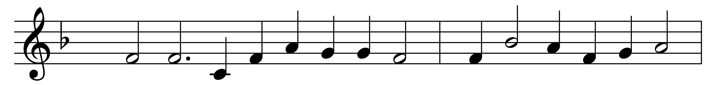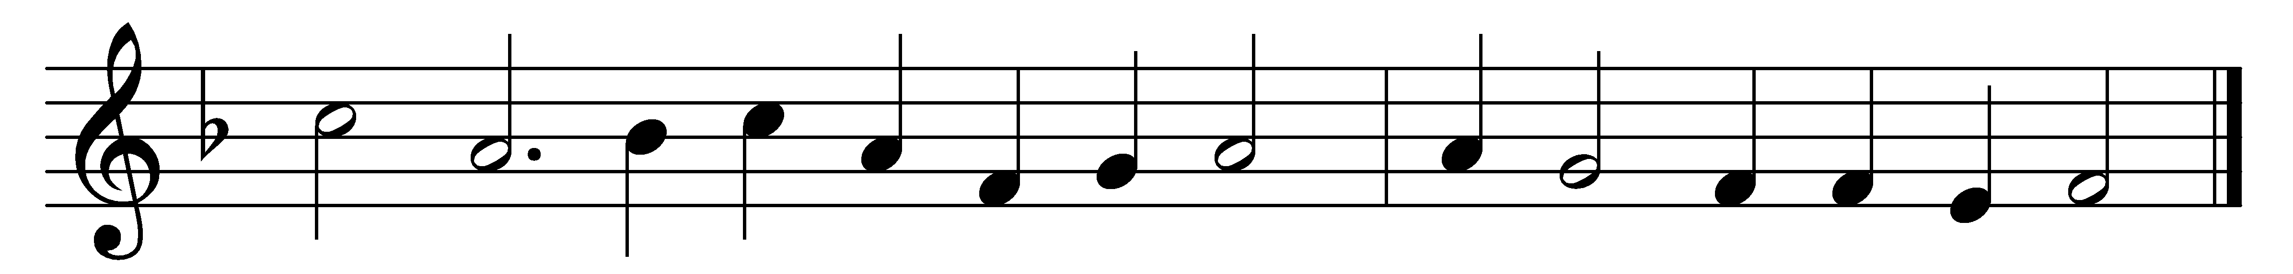

O God, unseen yet ever near,
thy presence may we feel;
and, thus inspired with holy fear,
before thine altar kneel.
Here may thy faithful people know
the blessings of thy love,
the streams that through the desert flow,
the manna from above.
We come, obedient to thy word,
to feast on heavenly food;
our meat the body of the Lord,
our drink his precious blood.
Thus may we all thy word obey,
for we, O God, are thine;
and go rejoicing on our way,
renewed with strength divine.

Words: Edward Osler (1798-1863)
Music: From Day’s Psalter, 1562

