Bread of heaven, on thee we feed Hymnal 1982 no. 323
Melody: Jesu, Jesu, du mein Hirt 7 7. 7 7. 7 7
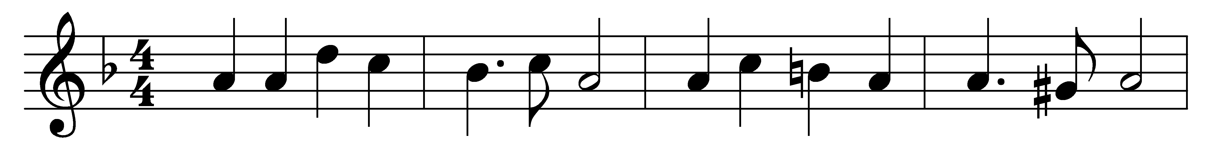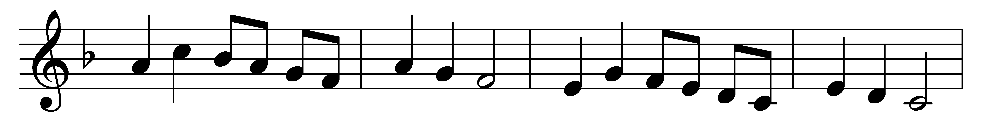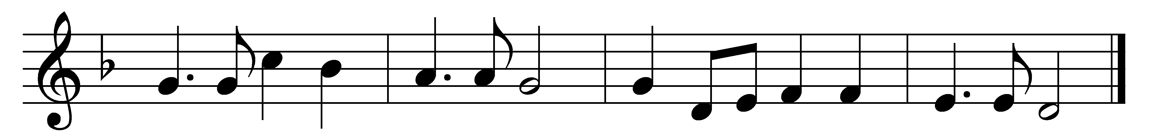

Bread of heaven, on thee we feed,
for thy Flesh is meat indeed;
ever may our souls be fed
with this true and living Bread;
day by day with strength supplied,
through the life of him who died.
Vine of heaven, thy Blood supplies
this blest cup of sacrifice;
Lord, thy wounds our healing give,
to thy cross we look and live:
Jesus, may we ever be
grafted, rooted, built in thee.

Words: Josiah Conder (1789-1855)
Music: Melody by Paul Heinlein (1626-1686), harmony from The English Hymnal, 1906

