All who believe and are baptized Hymnal 1982 no. 298 Melody: Es ist das Heil 8 7. 8 7. 8 8 7.
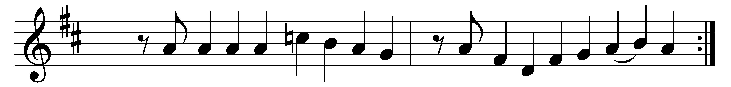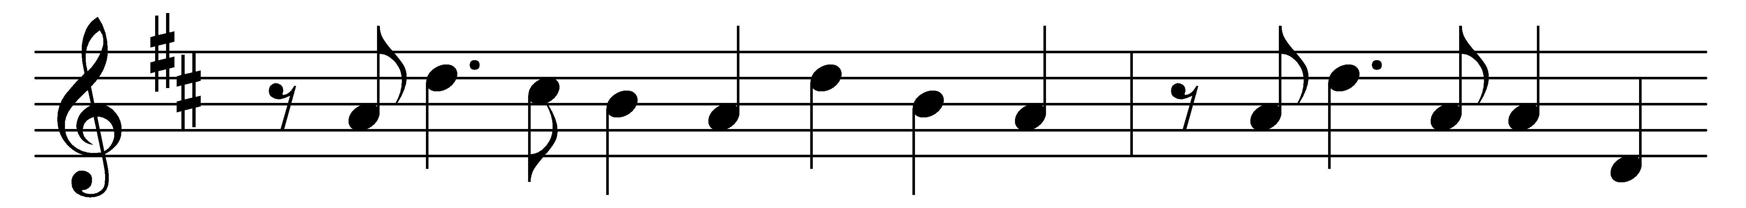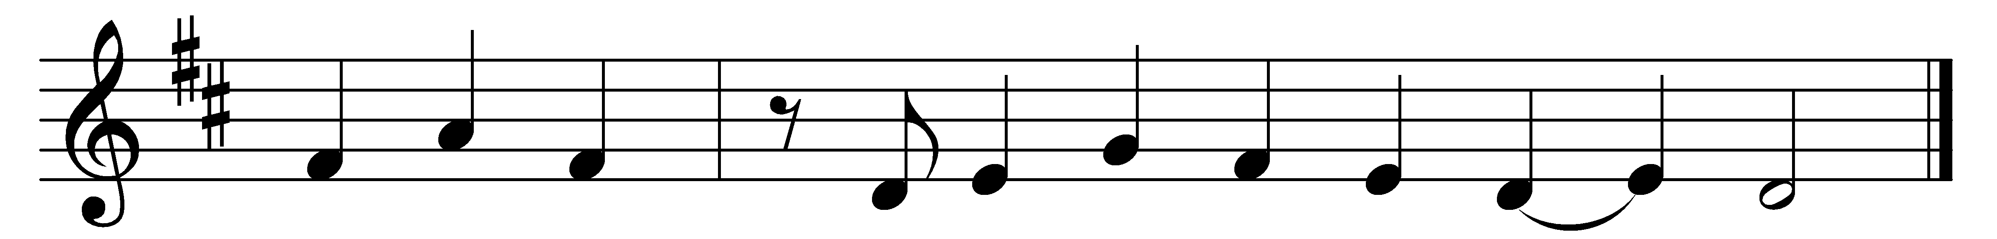

All who believe and are baptized
shall see the Lord’s salvation;
baptized into the death of Christ,
each is a new creation.
Through Christ’s redemption we shall stand
among the glorious heavenly band
of every tribe and nation.

With one accord, O God, we pray:
grant us thy Holy Spirit;
help us in our infirmity
through Jesus’ blood and merit.
Grant us to grow in grace each day
that as is promised here we may
eternal life inherit.

Words: Thomas Hansen Kingo (1634-1703), translated by George Alfred Taylor Rygh (1860-1942)
Music: Hans Leo Hassler (1564-1612)

