O Jesus, crowned with all renown Hymnal 1982 no. 292 Melody: Kingsfold D.C.M.
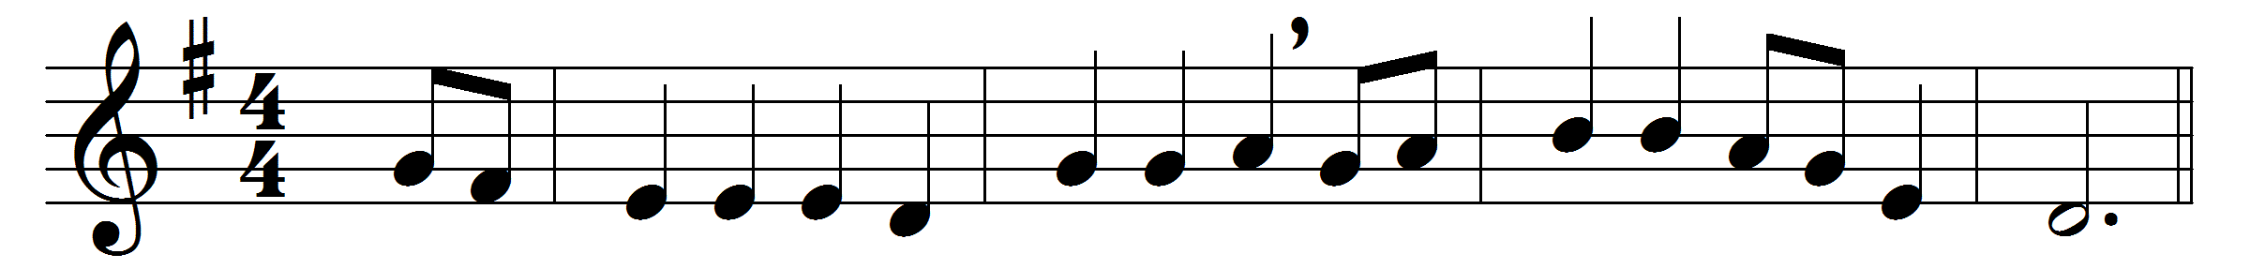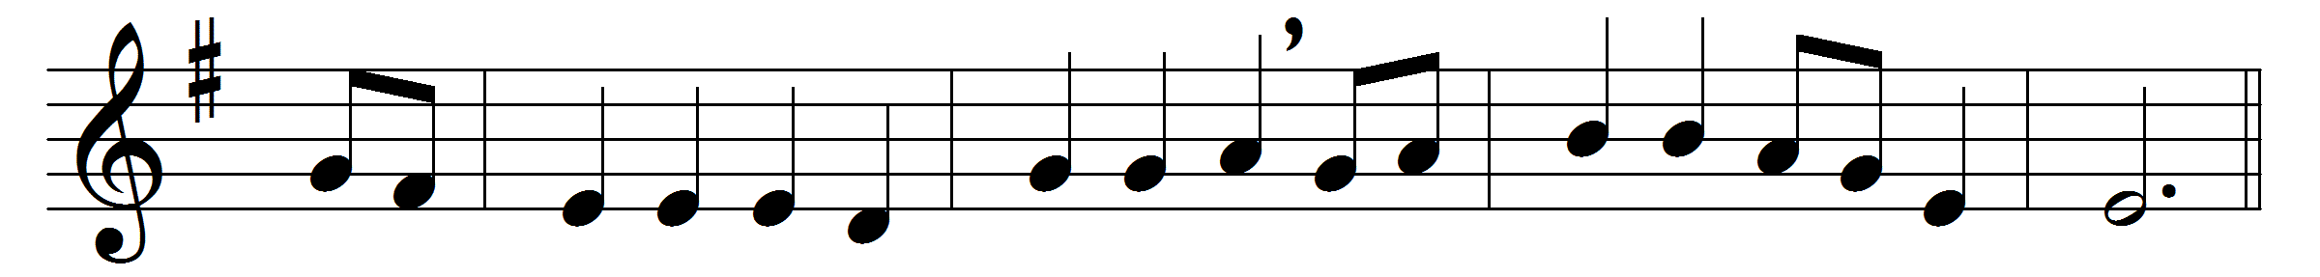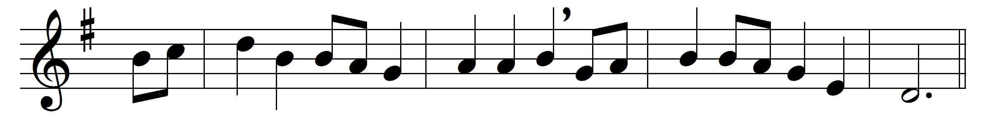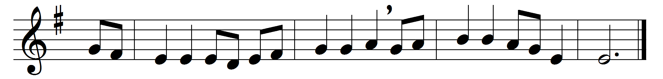

O Jesus, crowned with all renown,
since thou the earth hast trod,
thou reignest and by thee come down
henceforth the gifts of God.
Thine is the health and thine the wealth
that in our halls abound,
and thine the beauty and the joy
with which the years are crowned.

Lord, in their change, let frost and heat,
and winds and dews be given;
all fostering power, all influence sweet,
breath from the bounteous heaven.
Attemper fair with gentle air
the sunshine and the rain,
that kindly earth with timely birth
may yield her fruits again:

that we may feed the poor aright,
and, gathering round thy throne,
here, in the holy angels’ sight,
repay thee of thine own:
that we may praise thee all our days,
and with the Father’s Name,
and with the Holy Spirit’s gifts,
the Savior’s love proclaim.

Words: Edward White Benson (1829-1896)
Music: English traditional melody

