He sat to watch o’er customs paid Hymnal 1982 no. 281 Melody: Breslau L.M.
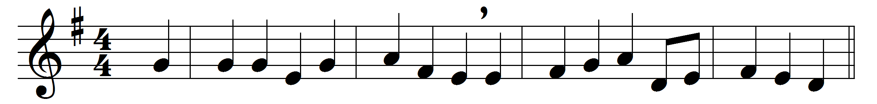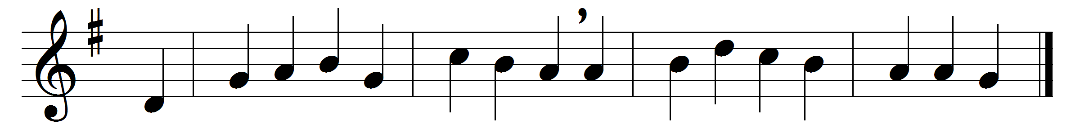

He sat to watch o’er customs paid,
a man of scorned and hardening trade,
alike the symbol and the tool
of foreign master’s hated rule.

But grace within his heart had stirred,
there needed but the timely word;
it came, true Lord of souls, from thee,
that royal summons, ‘Follow me.’

Enough, when thou wast passing by,
to hear thy voice, to meet thine eye;
he rose, responsive to the call,
and left his task, his gains, his all.

O wise exchange! with these to part,
and lay up treasures in the heart;
let them of Matthew’s wealth partake,
who yield up all for Jesus’ sake.

Words: William Bright (1824-1901)
Music: German traditional melody, harmony based on Felix Mendelssohn-Bartholdy (1809-1847)

