For thy blest saints, a noble throng Hymnal 1982 no. 276 Melody: St James C.M.
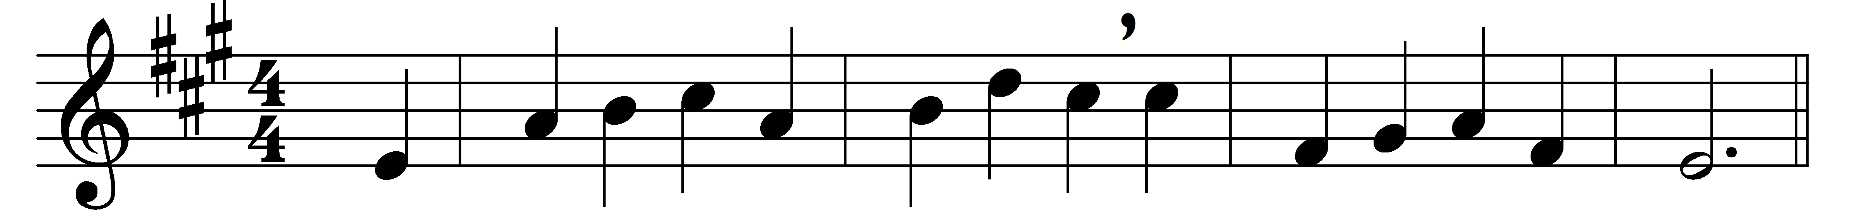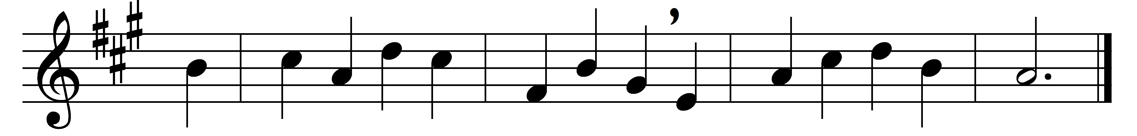

For thy blest saints, a noble throng,
who fell by fire and sword,
or early died or flourished long,
we praise thy Name, O Lord.

For James who left his father’s side,
not lingering by the sea:
he heard what could not be denied,
thy summons, ‘Follow me’;

he stood with thee beside the dead;
he climbed the mount with thee,
and saw the glory round thy head,
one of thy chosen three;

he knelt beneath the olive shade;
he drank thy cup of pain;
and slain by Herod’s flashing blade,
he saw thy face again.

Lord, may we learn to drink thy cup,
and meek and firm be found,
when thou shalt come to take us up
where thine elect are crowned.

Words: Cecil Frances Alexander (1818-1895)
Music: Raphael Courteville (d. 1772)

