Hark! the sound of holy voices Hymnal 1982 no. 275 Melody: In Babilone 8 7. 8 7. D.
Words from AMNS
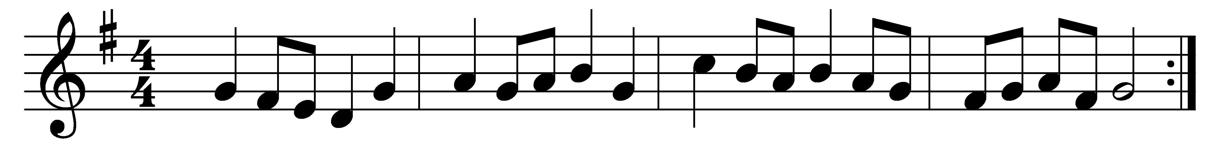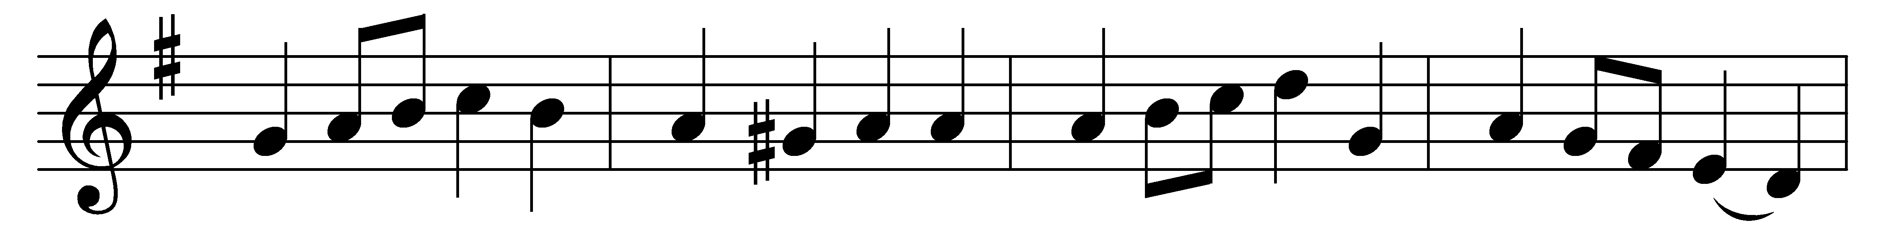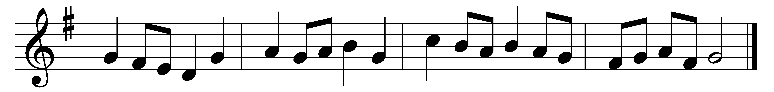

Hark! the sound of holy voices,
chanting at the crystal sea
Alleluia, Alleluia,
Alleluia, Lord, to thee:
multitude, which none can number,
like the stars in glory stands,
clothed in white apparel, holding
palms of victory in their hands.

Patriarch, and holy prophet,
who prepared the way of Christ,
king, apostle, saint, confessor,
martyr, and evangelist,
saintly maiden, godly matron,
widows who have watched to prayer,
joined in holy concert, singing
to the Lord of all, are there.

They have come from tribulation,
and have washed their robes in blood,
washed them in the blood of Jesus;
tried they were, and firm they stood:
mocked, imprisoned, stoned, tormented,
sawn asunder, slain with sword,
they have conquered death and Satan
by the might of Christ the Lord.

Marching with thy cross their banner,
they have triumphed following
thee, the Captain of Salvation,
thee their Saviour and their King:
gladly, Lord, with thee they suffered;
gladly, Lord, with thee they died,
and by death to life immortal
they were born, and glorified.

Now they reign in heavenly glory,
now they walk in golden light,
now they drink, as from a river,
holy bliss and infinite;
love and peace they taste for ever,
and all truth and knowledge see
in the beatific vision
of the blessèd Trinity.

God of God, the One-begotten,
Light of Light, Emmanuel,
in whose Body joined together
all the saints for ever dwell,
pour upon us of thy fulness,
that we may for evermore
God the Father, God the Son, and
God the Holy Ghost adore.

Words: Christopher Wordsworth (1807-1885)
Music: Melody from Oude en Nieuwe Hollantse Boerenlities en Contradansen, 1710

