The great forerunner of the morn Hymnal 1982 no. 271 Melody: Ut queant laxis L.M.
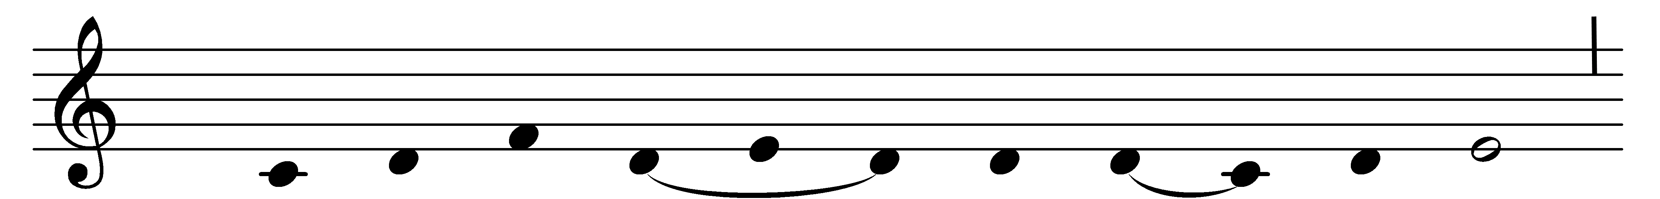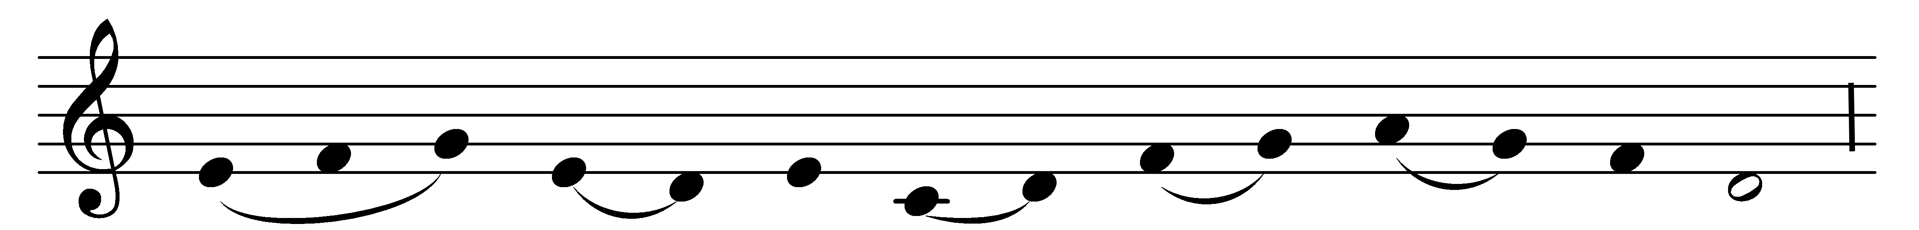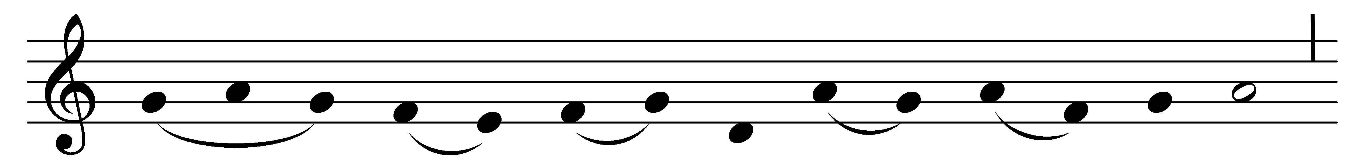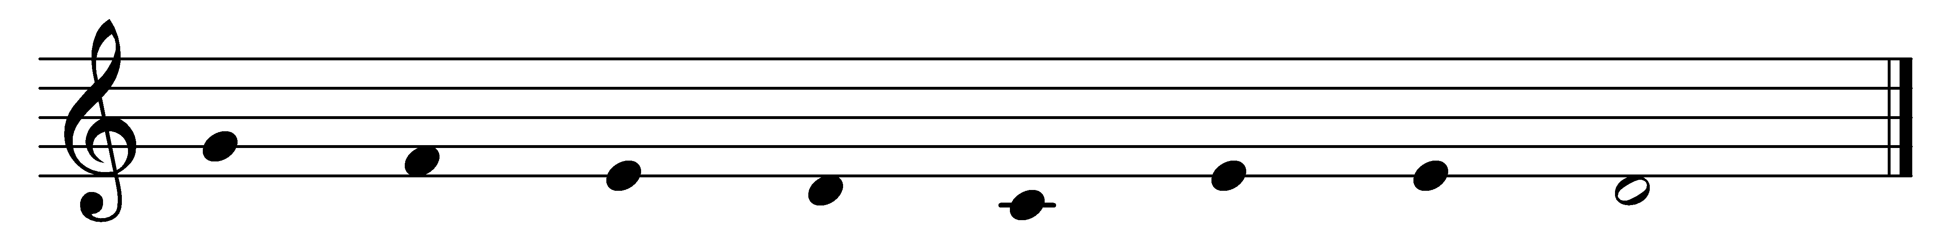

The great forerunner of the morn,
the herald of the Word, is born;
and faithful hearts shall never fail
with thanks and praise his light to hail.

With heavenly message Gabriel came,
that John should be that herald’s name,
and with prophetic utterance told
his actions great and manifold.

John, still unborn, yet gave aright
his witness to the coming light;
and Christ, the Sun of all the earth,
fulfilled that witness at his birth.

His mighty deeds exalt his fame
to greater than a prophet’s name;
of woman born shall never be
a greater prophet than was he.

To God the Father, God the Son,
and God the Spirit, Three in One,
praise, honor, might, and glory be
from age to age eternally.

Words: The Venerable Bede (673-735), translated by John Mason Neale (1818-1866)
Music: Mode ii, Theoretikerquellen MS, 12th century

