Gabriel’s message does away Hymnal 1982 no. 270 Melody: Angelus emittitur 7 7 7. with refrain
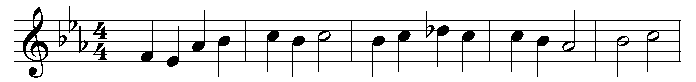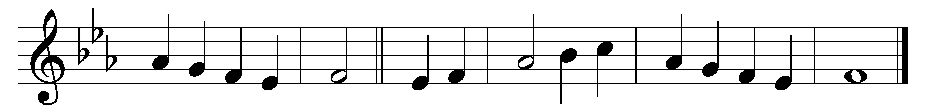

Gabriel’s message does away
Satan’s curse and Satan’s sway,
out of darkness brings our Day:
(Refrain:) so, behold, all the gates of heaven unfold.

He that comes despised shall reign;
he that cannot die, be slain;
death by death its death shall gain: (Refrain)

Weakness shall the strong confound;
by the hands, in grave clothes wound,
Adam’s chains shall be unbound: (Refrain)

Art by art shall be assailed;
to the cross shall Life be nailed;
from the grave shall hope be hailed: (Refrain)

Words: From Piae cantiones, 1582, translated by John Mason Neale (1818-1866)
Music: From Piae cantiones, 1582, harmonised by Richard Runciman Terry (1865-1938)

