The angel Gabriel from heaven came Hymnal 1982 no. 265
Melody: Gabriel’s Message 10 10. 12 10.
British spelling
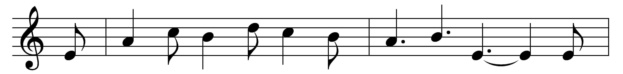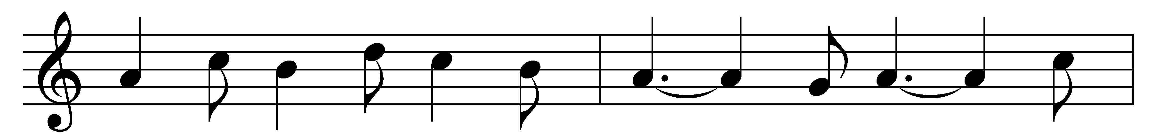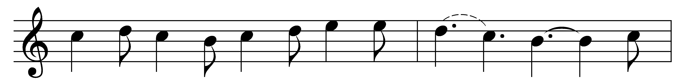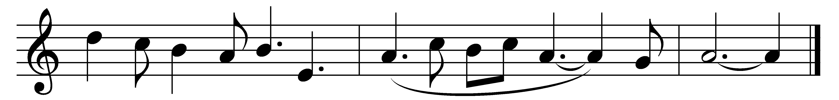

The angel Gabriel from heaven came,
his wings as drifted snow, his eyes as flame;
‘All hail,’ said he, ‘thou lowly maiden Mary,
most highly favoured lady!’ Gloria!

‘For known a blessèd mother thou shalt be,
all generations laud and honour thee,
thy son shall be Emmanuel, by seers foretold,
most highly favoured lady!’ Gloria!

Then gentle Mary meekly bowed her head,
‘To me be as it pleaseth God,’ she said,
‘My soul shall laud and magnify his holy name.’
Most highly favoured lady! Gloria!

Of her, Emmanuel, the Christ, was born
in Bethlehem, all on a Christmas morn,
and Christian folk throughout the world will ever say:
‘Most highly favoured lady!’ Gloria!

Words: Basque carol, paraphrased by Sabine Baring-Gould (1834-1924)
Music: Basque carol, harmonised by Edgar Pettman (1865-1943)

