O Zion, open wide thy gates Hymnal 1982 no. 257 Melody: Edmonton C.M.

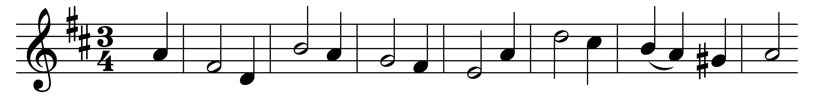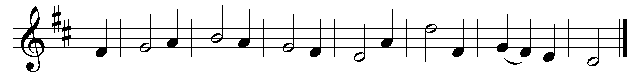

O Zion, open wide thy gates,
let symbols disappear;
a priest and victim, both in one,
the Truth himself, is here.

Aware of hidden deity,
the lowly Virgin brings
her newborn babe, with two young doves,
her humble offerings.

The aged Simeon sees at last
his Lord, so long desired,
and Anna welcomes Israel’s hope,
with holy rapture fired.

But silent knelt the mother blest
of the yet silent Word,
and pondering all things in her heart,
with speechless praise adored.

All glory to the Father be,
all glory to the Son,
all glory, Holy Ghost, to thee,
while endless ages run.

Words: Jean Baptiste de Santeüil (1630-1697), translated by Edward Caswall (1814-1878)
Melody: From Harmonia Sacra, c. 1760

