We sing the glorious conquest Hymnal 1982 no. 255 Melody: Munich 7 6. 7 6. D.
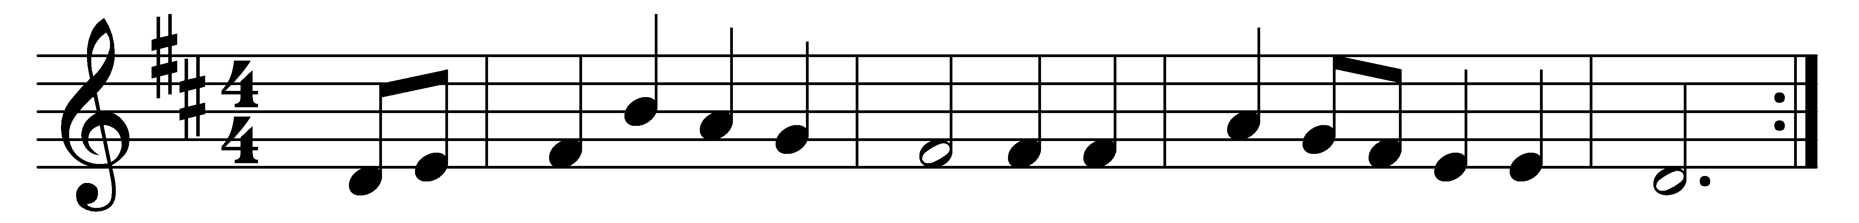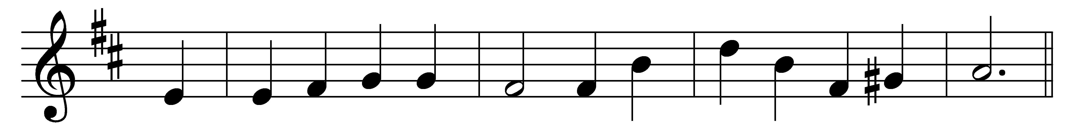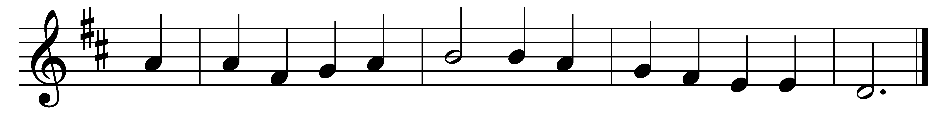

We sing the glorious conquest
before Damascus’ gate,
when Saul, the church’s spoiler
came spreading fear and hate.
God’s light shone down from heaven
and broke across the path.
His presence pierced and blinded
the zealot in his wrath.

O Voice that spoke within him;
O strong, reproving Word;
O Love that sought and held him
a prisoner of his Lord;
help us to know your kingship
that we, in every hour,
in all that may confront us,
will trust your hidden power.

Your grace, by ways mysterious,
our sinful wrath can bind,
and in those least expected
true servants you can find.
In us you seek disciples
to share your cross and crown
and give you final service
in glory at your throne.

Words: John Ellerton (1826-1893)
Melody: From Neu-vermehrtes und zu Übung Christl. Gottseligkeit eingerichtetes Meiningisches Gesangbuch, 1693, adapted and harmonised by Felix Mendelssohn (1809-1847)

