To the name of our salvation Hymns 1982 no. 249 Melody: Tantum ergo (Grafton) 8 7. 8 7. 8 7.
Words from AMNS
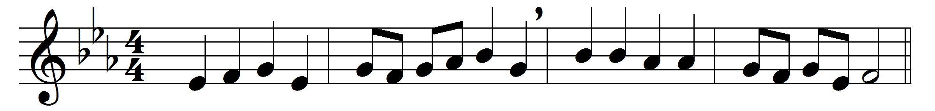
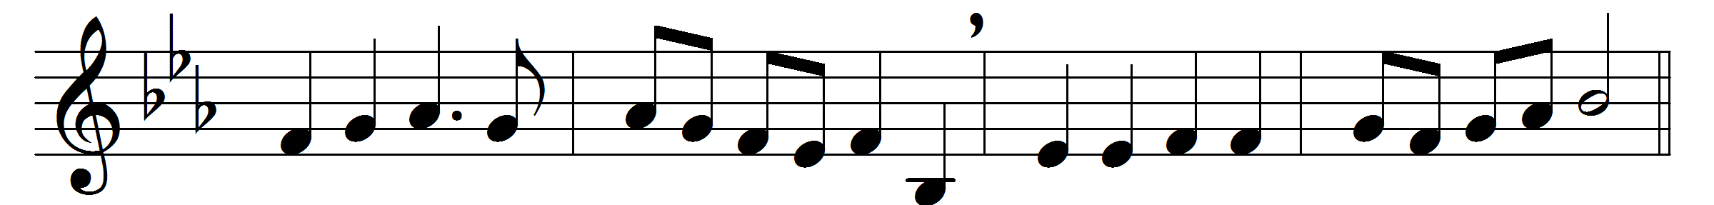
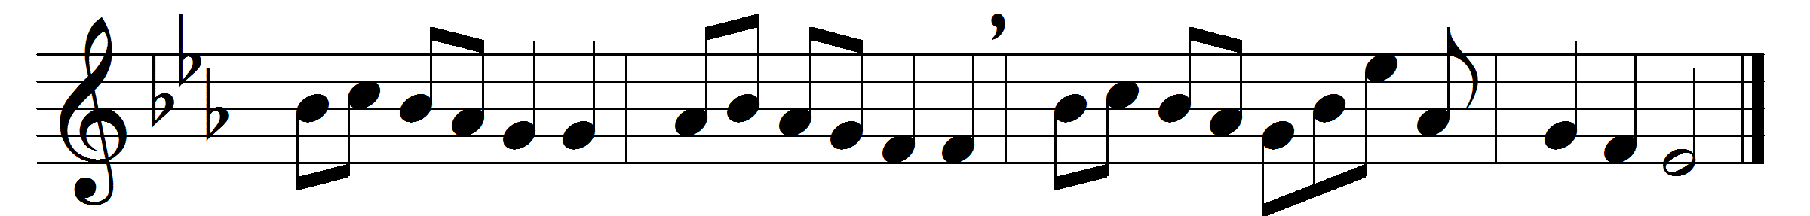

To the name of our salvation
laud and honour let us pay,
which for many a generation
hid in God’s foreknowledge lay,
but with holy exultation
we may sing aloud to-day.

Jesus is the name we treasure,
name beyond what words can tell;
name of gladness, name of pleasure,
ear and heart delighting well;
name of sweetness passing measure,
saving us from sin and hell.

’Tis the name for adoration,
name for songs of victory,
name for holy meditation
in this vale of misery,
name for joyful veneration
by the citizens on high.

’Tis the name that whoso preacheth
speaks like music to the ear;
who in prayer this name beseecheth
sweetest comfort findeth near;
who its perfect wisdom reacheth
heavenly joy possesseth here.

Jesus is the name exalted
over every other name;
in this name, whene’er assaulted,
we can put our foes to shame:
strength to them who else had halted,
eyes to blind, and feet to lame.

Therefore we in love adoring
this most blessèd name revere,
holy Jesu, thee imploring
so to write it in us here,
that hereafter heavenward soaring
we may sing with angels there.

Words: Latin, c. 15th century, translated by John Mason Neale (1818-1866)
Music: Melody from Chants ordinaires de l’Office Divin, 1881, harmony from Songs of Praise, 1925

