To the Name of our salvation Hymnal 1982 no. 249 Melody: Tantum ergo (Grafton) 8 7. 8 7. 8 7.
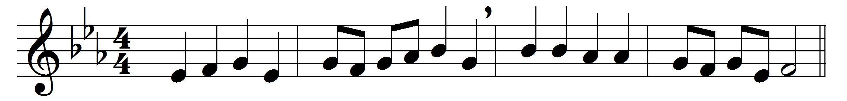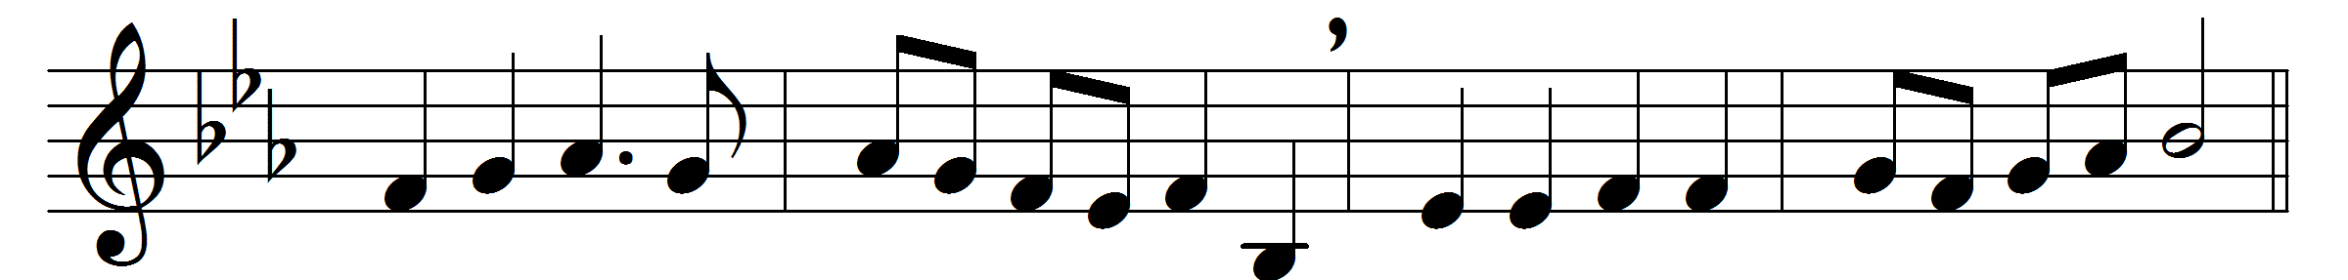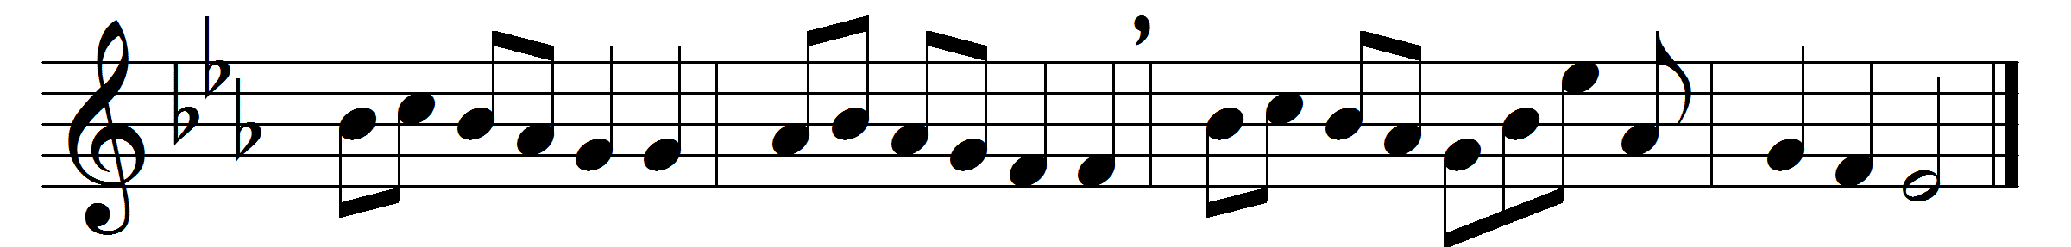

To the Name of our salvation
laud and honor let us pay,
which for many’a generation
hid in God’s foreknowledge lay;
but with holy exultation
we may sing aloud today.

Jesus is the Name we treasure;
Name beyond what words can tell;
Name of gladness, Name of pleasure,
ear and heart delighting well;
Name of sweetness, passing measure,
saving us from sin and hell.

’Tis the Name that whoso preacheth
speaks like music to the ear;
who in prayer this Name beseecheth
sweetest comfort findeth near;
who its perfect wisdom reacheth,
heavenly joy possesseth here.

Therefore we, in love adoring,
this most blessed Name revere,
holy Jesus, thee imploring
so to write it in us here
that hereafter, heavenward soaring,
we may sing with angels there.

Words: Latin, 15th century, translation from Hymns Ancient & Modern, 1861
Music: Melody from Chants ordinaires de l’Office Divin, 1881, harmony from Songs of Praise, 1925

