Let us now our voices raise Hymnal 1982 no. 237
Melody: Ave virgo virginum / Gaudeamus pariter 7 6. 7 6. D.
British spelling
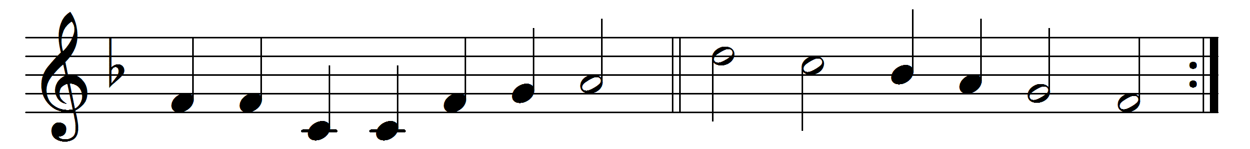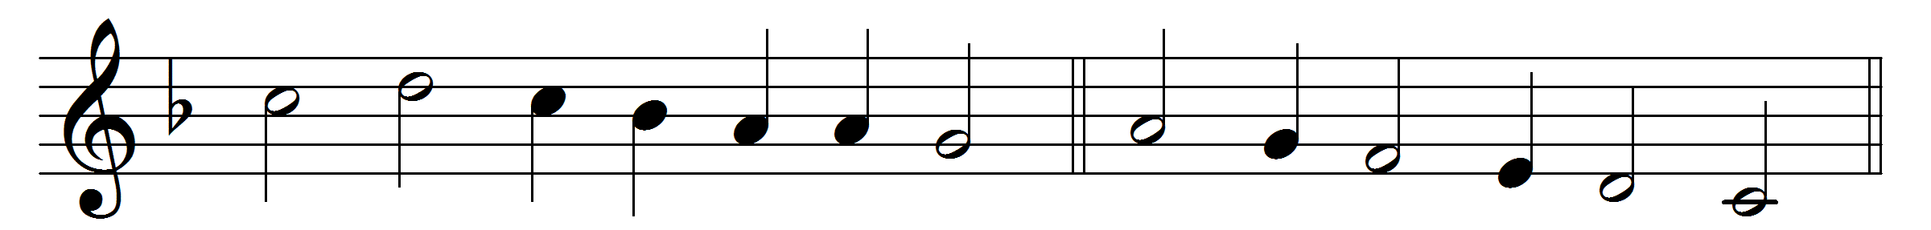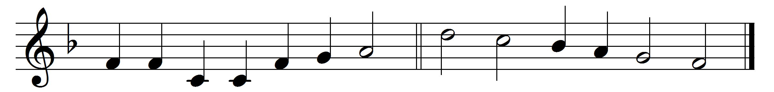

Let us now our voices raise,
wake the day with gladness;
God himself to joy and praise
turns our human sadness;
joy that martyrs won their crown,
opened heaven’s portal,
when they laid the mortal down
for the life immortal.

Never flinched they from the flame,
from the torment never;
vain the tyrant’s sharpest aim,
vain each fierce endeavour:
for by faith they saw the land
decked in all its glory,
where triumphant now they stand
with the victor’s story.

Up and follow, Christians all:
press through toil and sorrow;
turn from fear, and heed the call
to a glorious morrow!
Who will venture on the strife;
who will first begin it?
Who will grasp the land of Life?
Christians, up and win it!

Words: Joseph the Hymnographer (9th century), translated by John Mason Neale (1818-1866)
Music: Melody as given by Johann Horn, 1544

