Hail this joyful day’s return Hymnal 1982 no. 223 Melody: Beata nobis gaudia 7 7. 7 7.

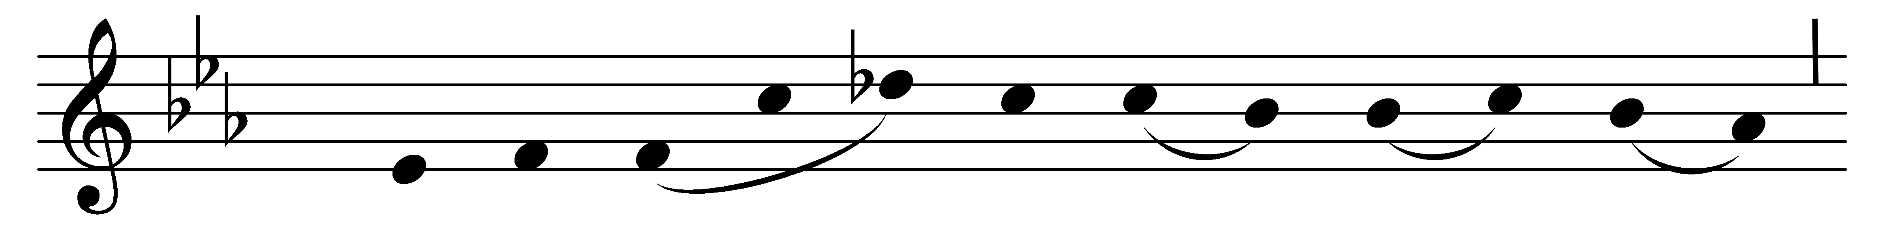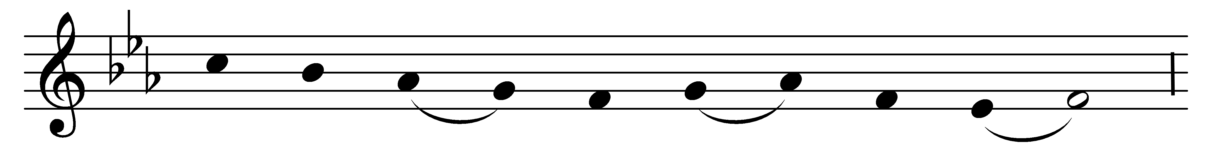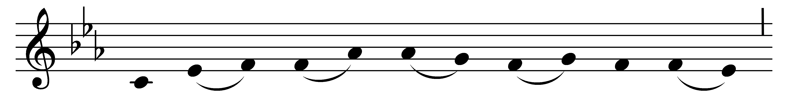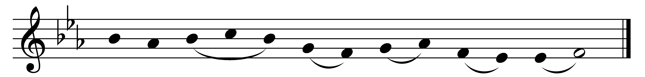

Hail this joyful day’s return,
hail the Pentecostal morn,
morn when our ascended Lord
on his Church his Spirit poured!

Like to cloven tongues of flame
on the twelve the Spirit came –
tongues, that earth may hear their call,
fire, that love may burn in all.

Lord, to you your people bend;
unto us your Spirit send;
blessings of this sacred day
grant us, dearest Lord, we pray.

You who did our forebears guide,
with their children still abide;
grant us pardon, grant us peace,
till our earthly wanderings cease.

Words: Attributed to Hilary of Poitiers (4th century), translated by Robert Campbell (1814-1868)
Music: Mode i, Zisterzienser Hymnar, 14th century

