Awake, arise, lift up your voice Hymnal 1982 no. 212 Melody: Richmond C.M.
British spelling
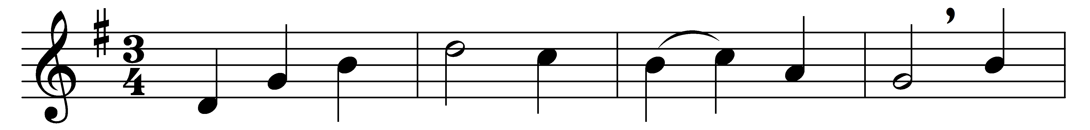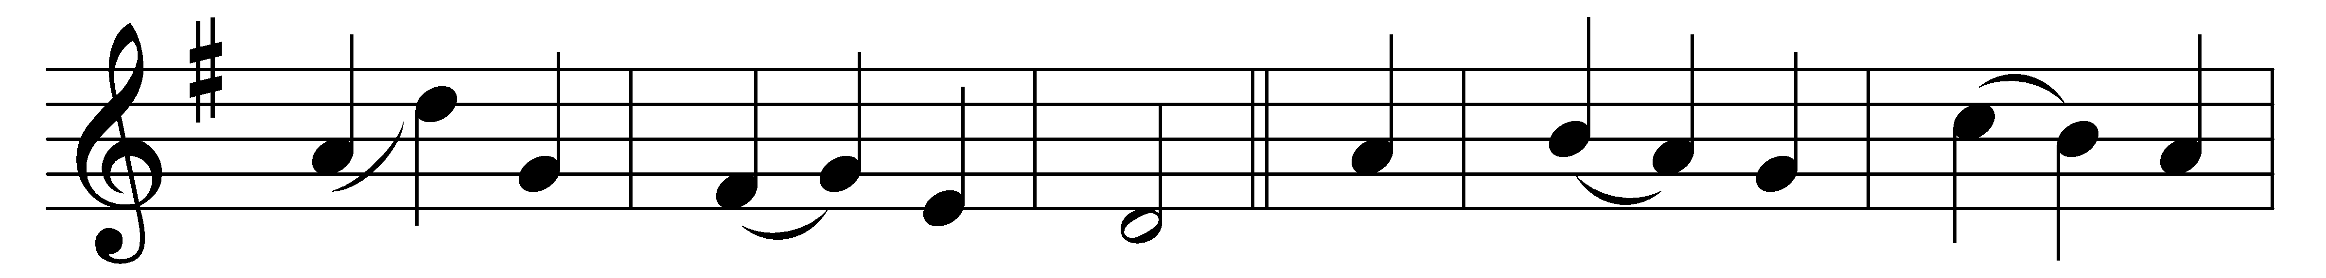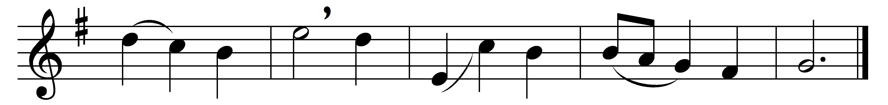

Awake, arise, lift up your voice,
let Easter music swell;
rejoice in Christ, again rejoice
and on his praises dwell.

Oh, with what gladness and surprise
the saints their Saviour greet;
nor will they trust their ears and eyes
but by his hands and feet,

those hands of liberal love indeed
in infinite degree,
those feet still free to move and bleed
for millions and for me.

His enemies had sealed the stone
as Pilate gave them leave,
lest dead and friendless and alone
he should their skill deceive.

O Dead arise! O Friendless stand
by seraphim adored!
O Solitude again command
your host from heaven restored!

Words: Christopher Smart (1722-1771)
Music: Melody adapted from Thomas Haweis (1734-1820) by Samuel Webbe (1740-1816)

