O sons and daughters, let us sing! Hymnal 1982 no. 206
Melody: O filii et filiae 8 8 8. with Alleluias
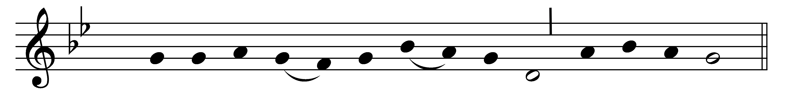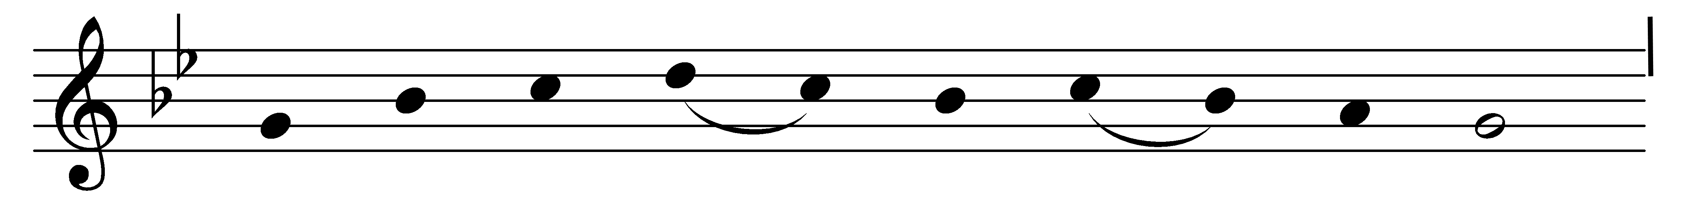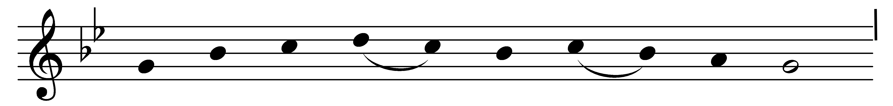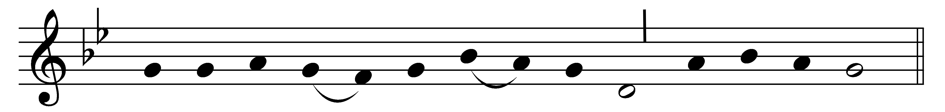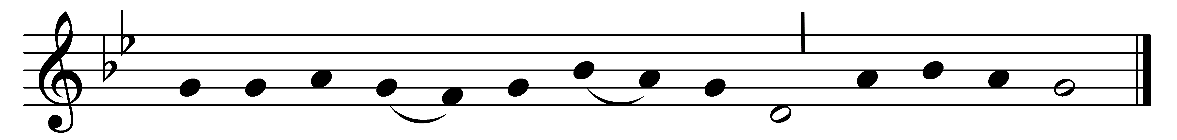

Alleluia, alleluia, alleluia!

O sons and daughters, let us sing!
The King of heaven, the glorious King,
o’er death and hell rose triumphing.
Alleluia!

That night th’apostles met in fear;
amidst them came their Lord most dear,
and said, ‘My peace be on all here.’
Alleluia!

When Thomas first the tidings heard,
how they had seen the risen Lord,
he doubted the disciples’ word.
Alleluia!

‘My piercèd side, O Thomas, see;
my hands, my feet, I show to thee;
not faithless, but believing be.’
Alleluia!

No longer Thomas then denied,
he saw the feet, the hands, the side;
‘Thou art my Lord and God,’ he cried.
Alleluia!

How blest are they who have not seen,
and yet whose faith has constant been,
for they eternal life shall win.
Alleluia!

Alleluia, alleluia, alleluia!

Words: Jean Tisserand (d. 1419), translated by John Mason Neale (1818-1866)
Music: From Airs sur les hymnes sacrez, odes et noëls, 1623

