Come, ye faithful, raise the strain Hymnal 1982 no. 200 / AMNS 76
Melody: Ave virgo virginum / Gaudeamus pariter 7 6. 7 6. D.
AMNS words – identical with AMNS 76 (tune AMNS 443)
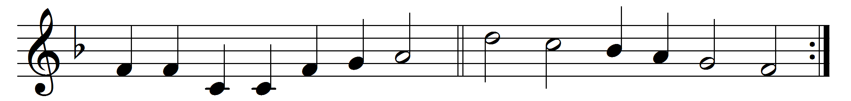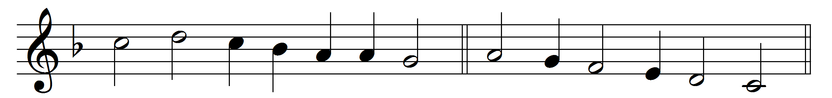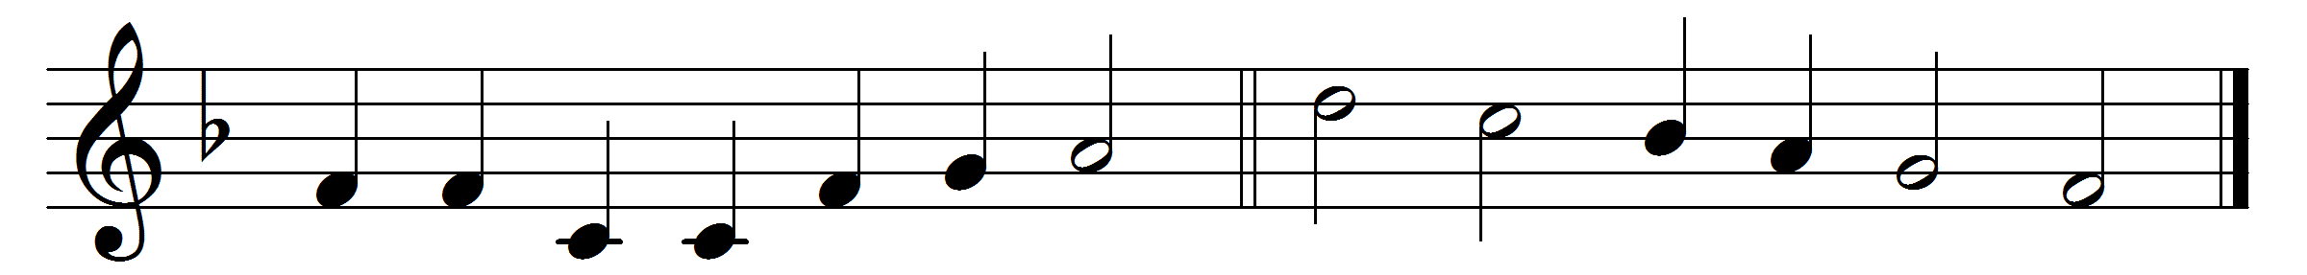

Come, ye faithful, raise the strain
of triumphant gladness!
God hath brought his Israel
into joy from sadness;
loosed from Pharaoh’s bitter yoke
Jacob’s sons and daughters;
led them with unmoistened foot
through the Red Sea waters.
’Tis the spring of souls to-day;
Christ hath burst his prison,
and from three days’ sleep in death
as a sun hath risen:
all the winter of our sins,
long and dark, is flying
from his light, to whom we give
laud and praise undying.
Now the queen of seasons, bright
with the day of splendour,
with the royal feast of feasts,
comes its joy to render;
comes to glad Jerusalem,
who with true affection
welcomes in unwearied strains
Jesu’s resurrection.
Alleluia now we cry
to our King immortal,
who triumphant burst the bars
of the tomb’s dark portal;
Alleluia, with the Son
God the Father praising;
Alleluia yet again
to the Spirit raising.

Words: St. John of Damascus (d. c. 754), translated by John Mason Neale (1818-1866)
Music: Melody as given by Johann Horn, 1544

