Come, ye faithful, raise the strain Hymnal 1982 no. 199 Melody: St Kevin 7 6. 7 6. D.
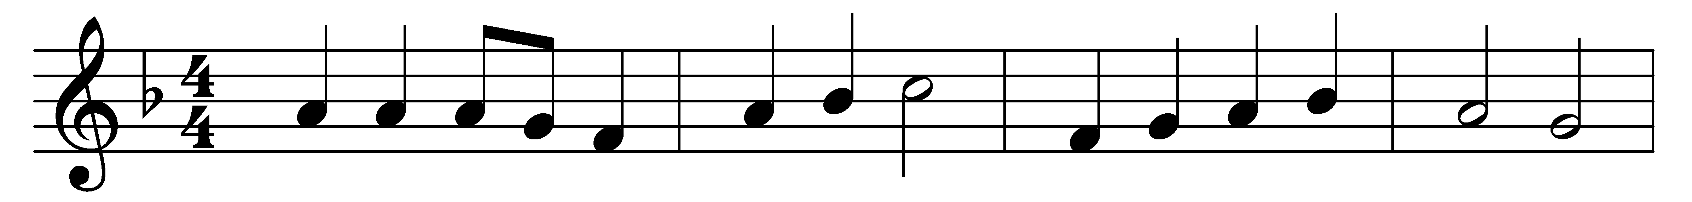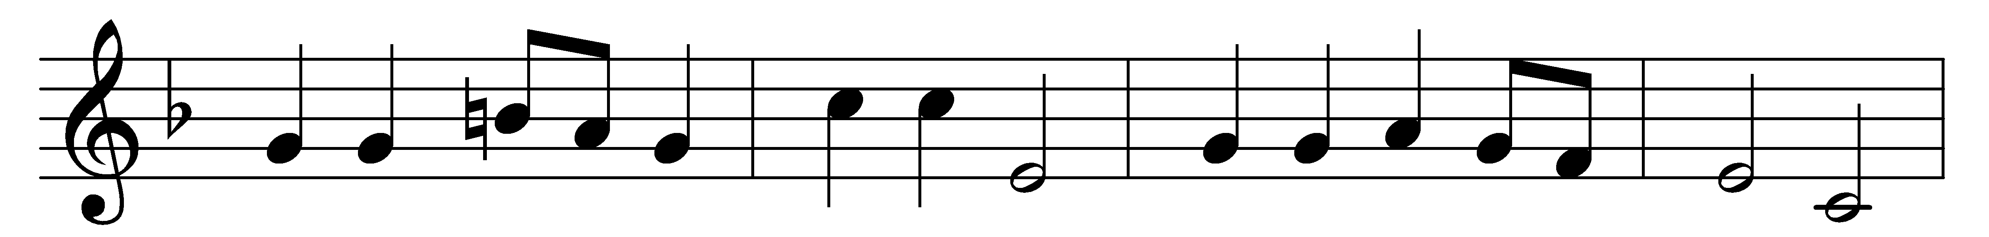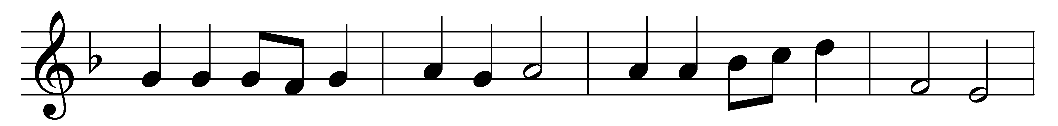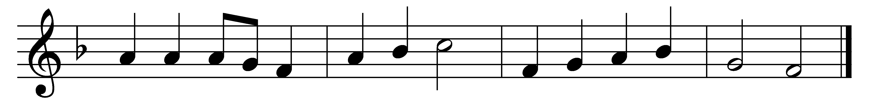

Come, ye faithful, raise the strain
of triumphant gladness!
God hath brought his Israel
into joy from sadness:
loosed from Pharaoh’s bitter yoke
Jacob’s sons and daughters,
led them with unmoistened foot
through the Red Sea waters.

’Tis the spring of souls today:
Christ hath burst his prison,
and from three days’ sleep in death
as a sun hath risen;
all the winter of our sins,
long and dark, is flying
from his light, to whom we give
laud and praise undying.

Now the queen of seasons, bright
with the day of splendor,
with the royal feast of feasts,
comes its joy to render;
comes to glad Jerusalem,
who with true affection
welcomes in unwearied strains
Jesus’ resurrection.

Neither might the gates of death,
nor the tomb’s dark portal,
nor the watchers, nor the seal
hold thee as a mortal:
but today amidst thine own
thou didst stand, bestowing
that thy peace which evermore
passeth human knowing.

Words: St. John of Damascus (d. c. 754), translated by John Mason Neale (1818-1866)
Music: Arthur Seymour Sullivan (1842-1900)

