Thou hallowed chosen morn of praise Hymnal 1982 no. 198
Melody: Mach’s mit mir, Gott 8 7. 8 7. 8 8.

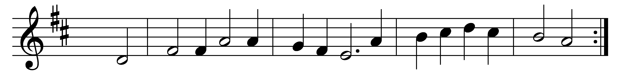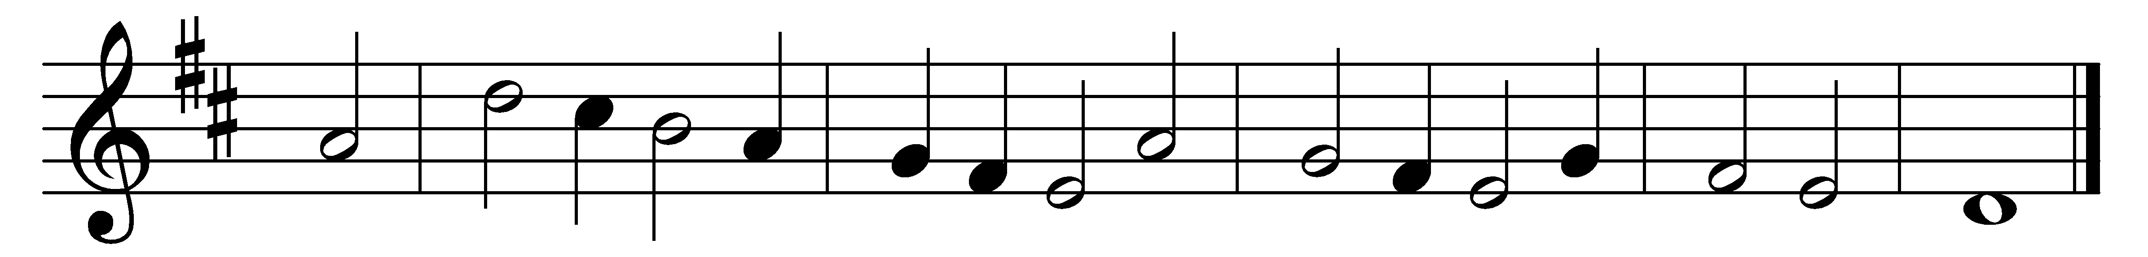

Thou hallowed chosen morn of praise,
that best and greatest shinest:
fair Easter, queen of all the days,
of seasons, best, divinest!
Christ rose from death; and we adore
for ever and for evermore.

Come, let us taste the vine’s new fruit,
for heavenly joy preparing;
today the branches with the root
in resurrection sharing:
whom as true God our hymns adore
for ever and for evermore.

Words: John of Damascus (8th century), translated by John Mason Neale (1818-1866)
Music: Melody from Das ander Theil des andern newen Operis Geistlicher Deutscher Lieder, 1605, adapted and harmonised by Johann Hermann Schein (1586-1630)

