Christians, to the Paschal victim Hymnal 1982 no. 183
Melody: Victimae Paschali laudes Irregular metre

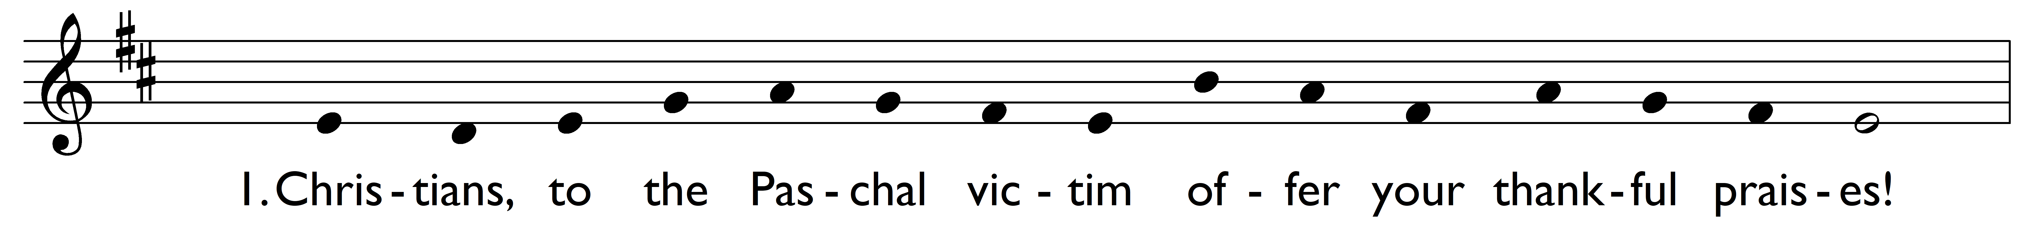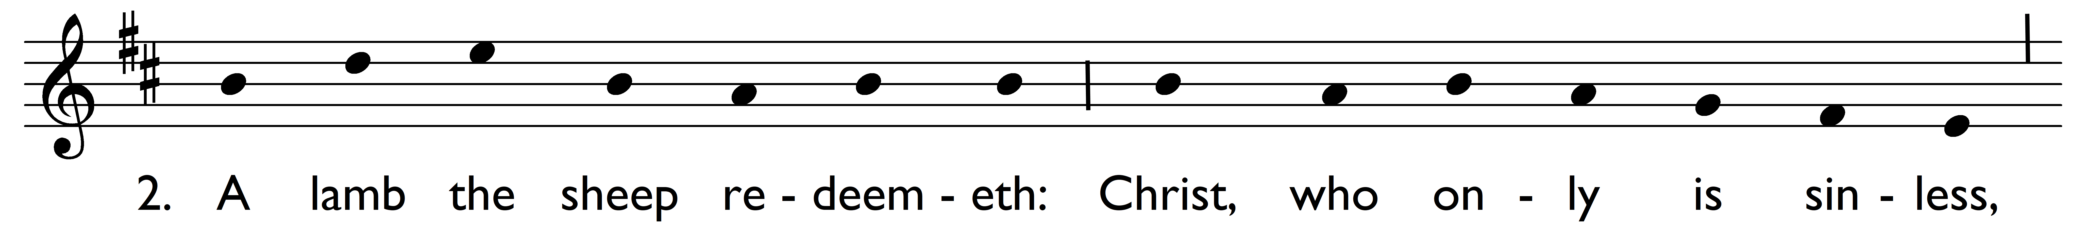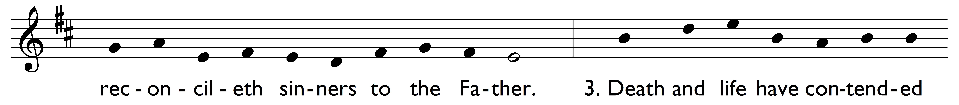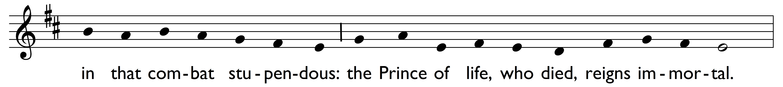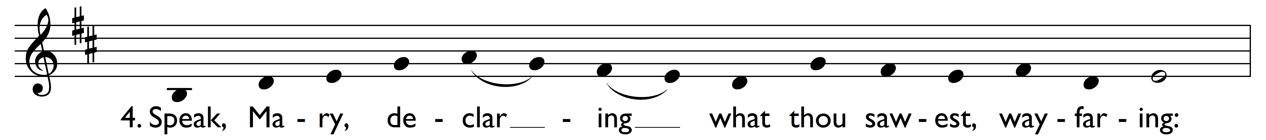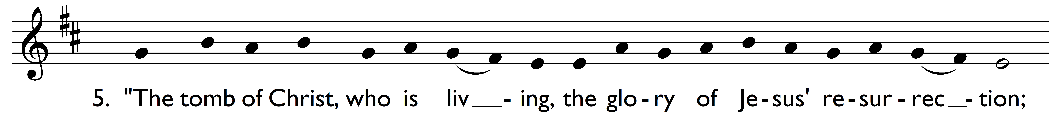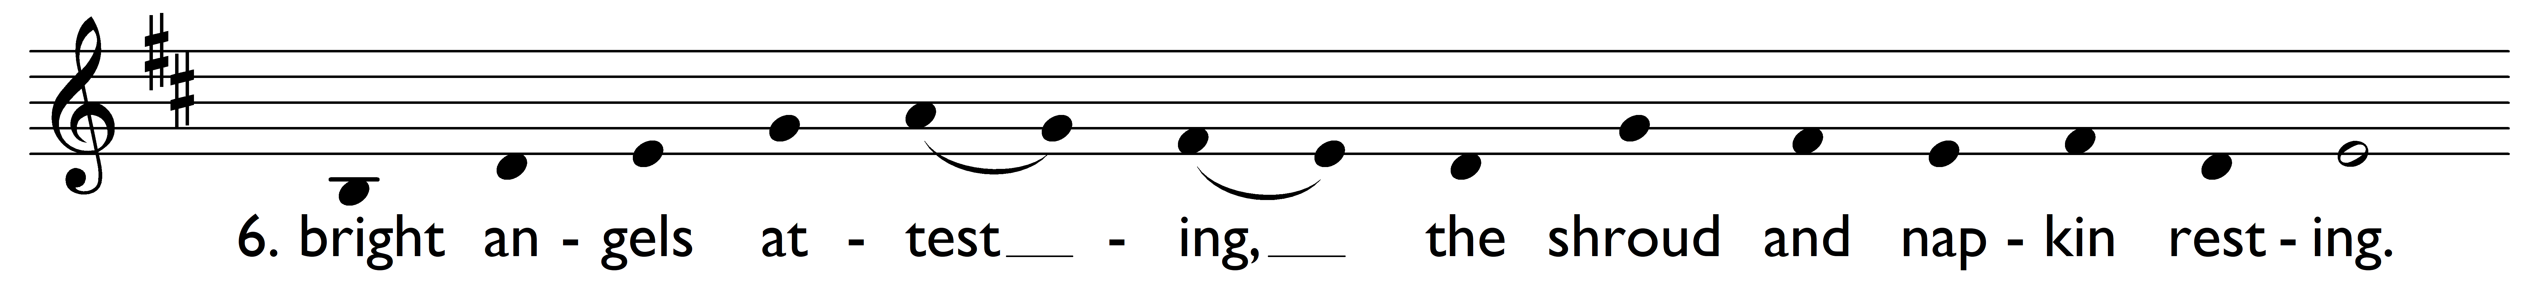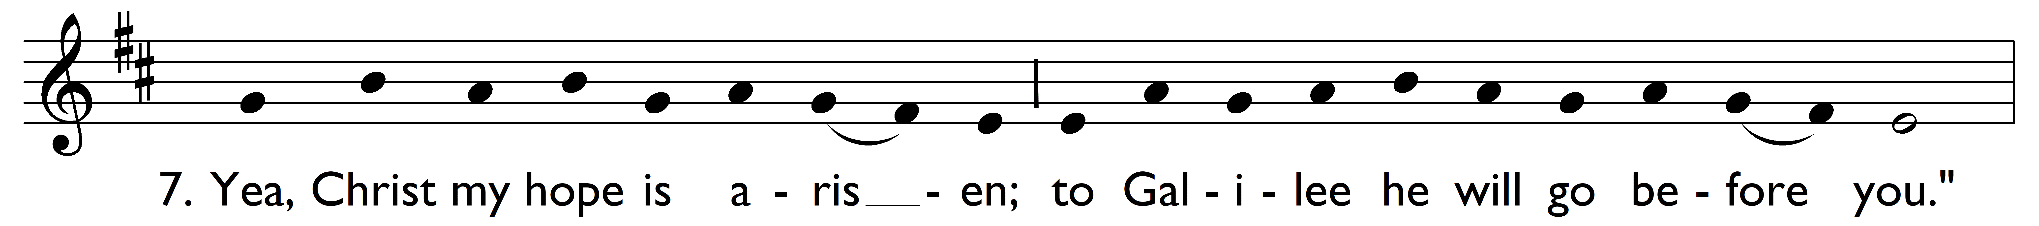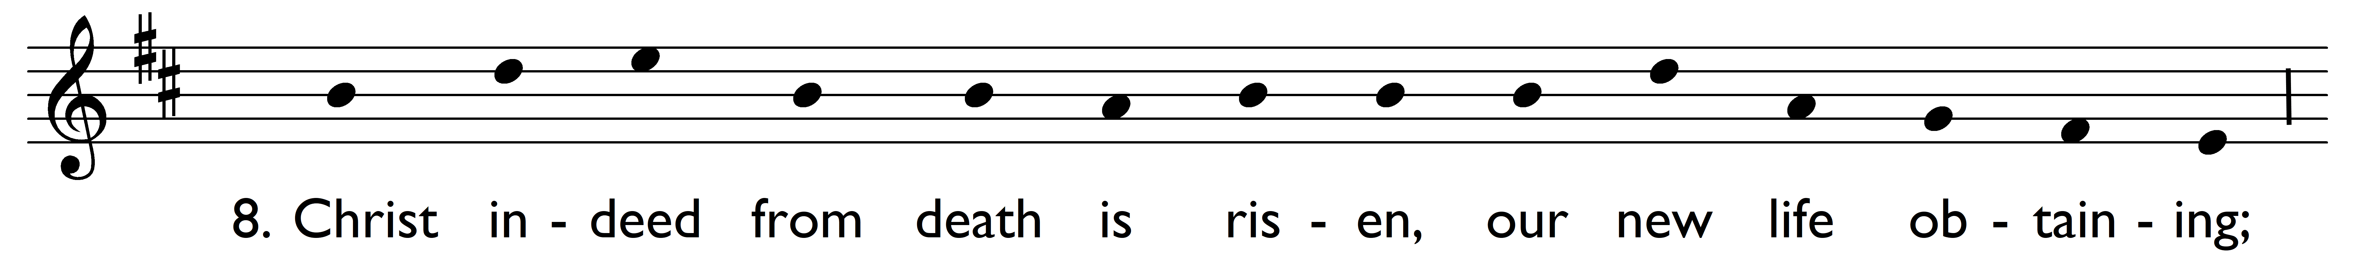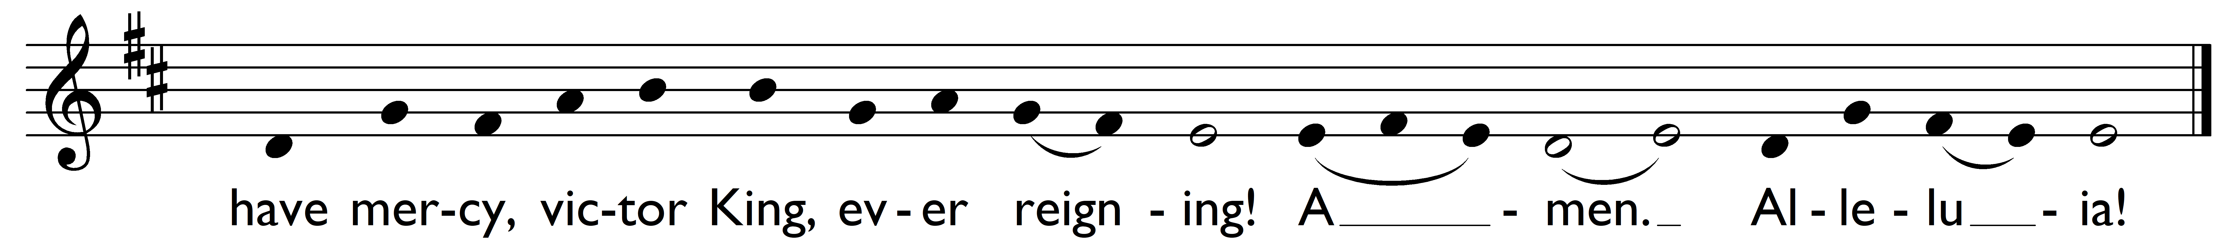

Christians, to the Paschal victim
offer your thankful praises!

A lamb the sheep redeemeth:
Christ, who only is sinless,
reconcileth sinners to the Father.

Death and life have contended
in that combat stupendous:
the Prince of life, who died,
reigns immortal.

Speak, Mary, declaring
what thou sawest, wayfaring:

‘The tomb of Christ, who is living,
the glory of Jesus’ resurrection;

bright angels attesting,
the shroud and napkin resting.

Yea, Christ my hope is arisen;
to Galilee he will go before you.’

Christ indeed from death is risen,
our new life obtaining;
have mercy, victor King, ever reigning!

Amen. Alleluia!

Words: Wigbert (Wipo of Burgundy) (d. 1050?), translation from The Antiphoner and Grail, 1880
Music: Mode i, attributed to Wigbert

