He is risen, he is risen! Hymnal 1982 no. 180 Melody: Unser Herrscher (Neander) 8 7. 8 7. 7 7.
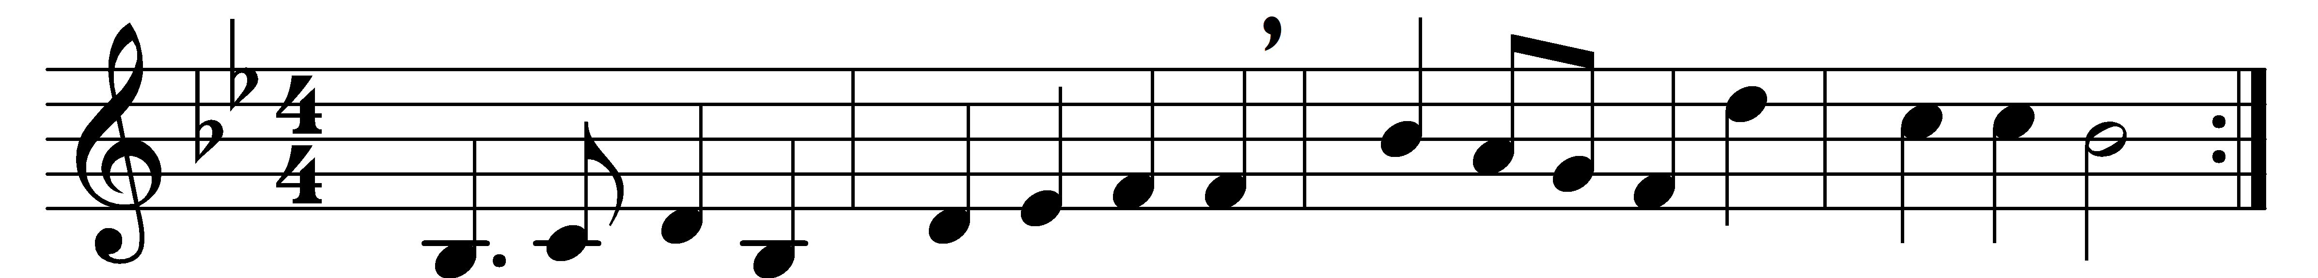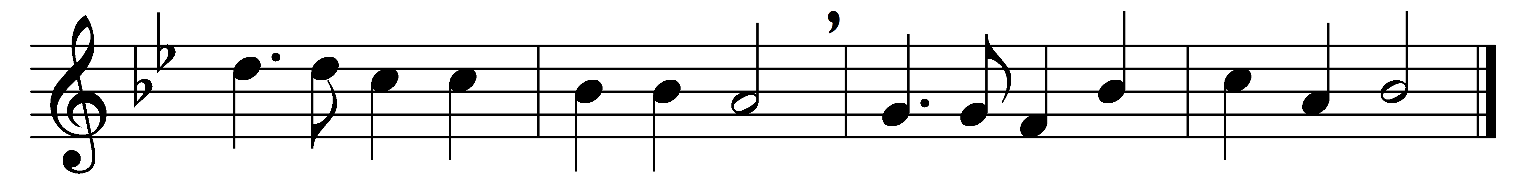

He is risen, he is risen!
Tell it out with joyful voice:
he has burst his three days’ prison;
let the whole wide earth rejoice:
death is conquered, we are free,
Christ has won the victory.

Come, ye sad and fearful-hearted,
with glad smile and radiant brow!
Death’s long shadows have departed;
Jesus’ woes are over now,
and the passion that he bore –
sin and pain can vex no more.

Come, with high and holy hymning,
hail our Lord’s triumphant day;
not one darksome cloud is dimming
yonder glorious morning ray,
breaking o’er the purple east,
symbol of our Easter feast.

He is risen, he is risen!
He hath opened heaven’s gate:
we are free from sin’s dark prison,
risen to a holier state;
and a brighter Easter beam
on our longing eyes shall stream.

Words: Cecil Frances Alexander (1818-1895)
Music: Joachim Neander (1650-1680)

