Were you there when they crucified my Lord? Hymnal 1982 no. 172
Melody: Were You There Irregular metre
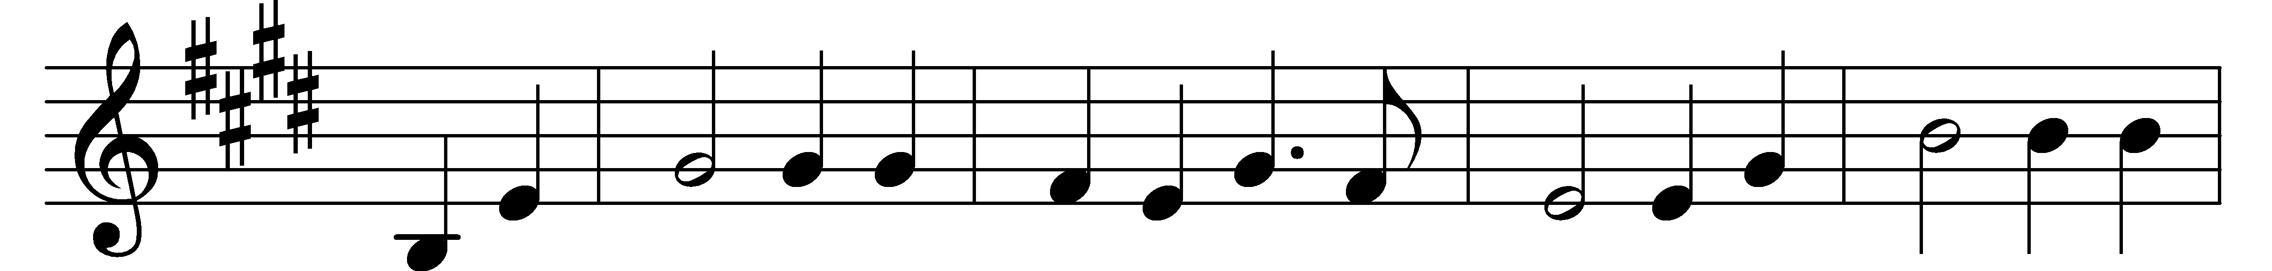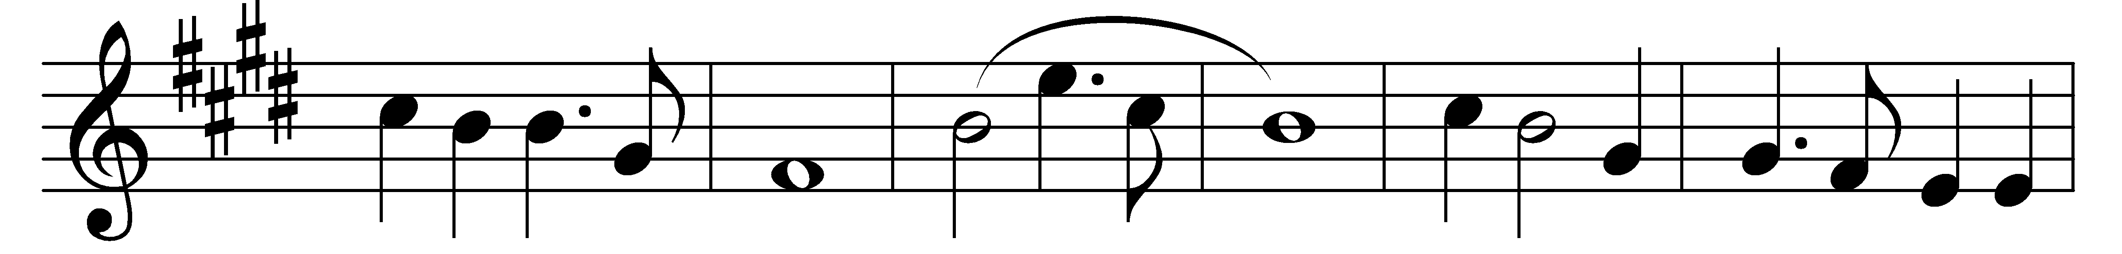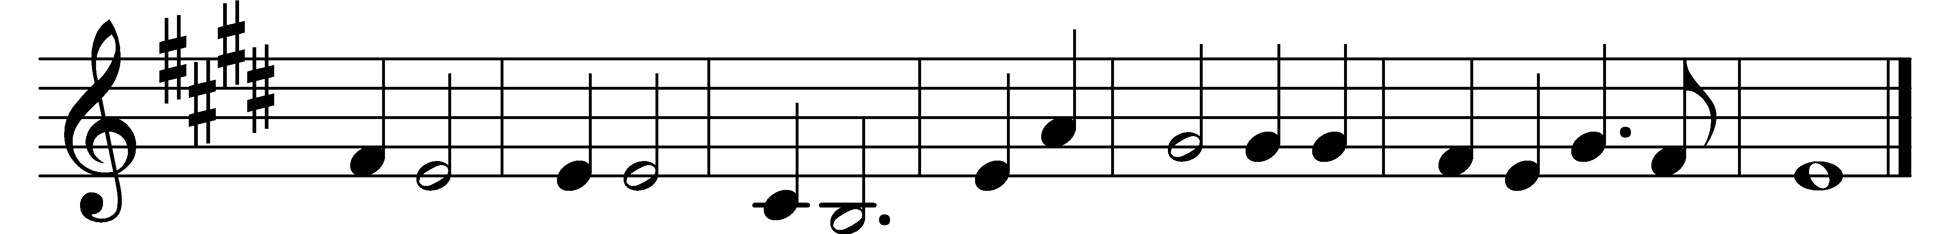

Were you there when they crucified my Lord?
Were you there when they crucified my Lord?
Oh!
Sometimes it causes me to tremble, tremble, tremble.
Were you there when they crucified my Lord?

Were you there when they nailed him to the tree?
Were you there when they nailed him to the tree?
Oh!
Sometimes it causes me to tremble, tremble, tremble.
Were you there when they nailed him to the tree?

Were you there when they pierced him in the side?
Were you there when they pierced him in the side?
Oh!
Sometimes it causes me to tremble, tremble, tremble.
Were you there when they pierced him in the side?

Were you there when they laid him in the tomb?
Were you there when they laid him in the tomb?
Oh!
Sometimes it causes me to tremble, tremble, tremble.
Were you there when they laid him in the tomb?

Words: Afro-American spiritual
Music: Afro-American spiritual, harmonised by Charles Winfred Douglas (1867-1944)

