Go to dark Gethsemane Hymnal 1982 no. 171 Melody: Petra 7 7. 7 7. 7 7.
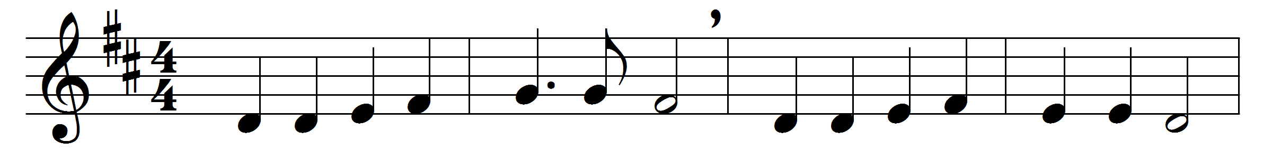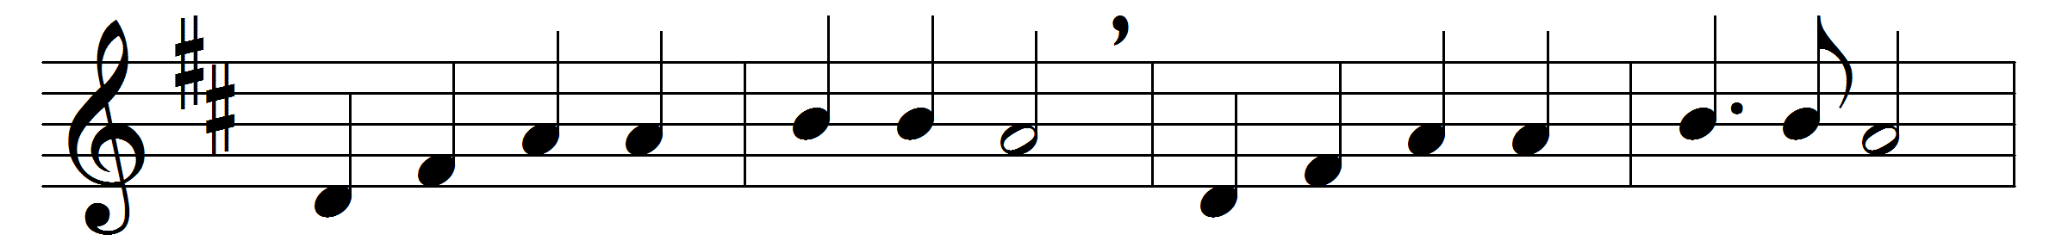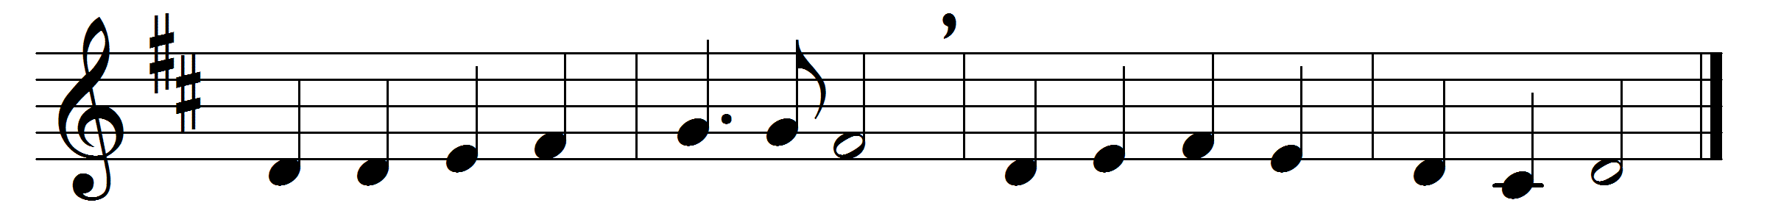

Go to dark Gethsemane,
ye that feel the tempter’s power;
your Redeemer’s conflict see,
watch with him one bitter hour;
turn not from his griefs away,
learn of Jesus Christ to pray.

Follow to the judgment hall;
view the Lord of life arraigned;
O the wormwood and the gall!
O the pangs his soul sustained!
Shun not suffering, shame, or loss;
learn of him to bear the cross.

Calv’ry’s mournful mountain climb;
there, adoring at his feet,
mark the miracle of time,
God’s own sacrifice complete;
‘It is finished!’ hear him cry;
learn of Jesus Christ to die.

Words: James Montgomery (1771-1854)
Music: Richard Redhead (1820-1901)

