O sacred head, sore wounded Hymnal 1982 no. 168
Melody: Herzlich tut mich verlangen 7 6. 7 6. D.
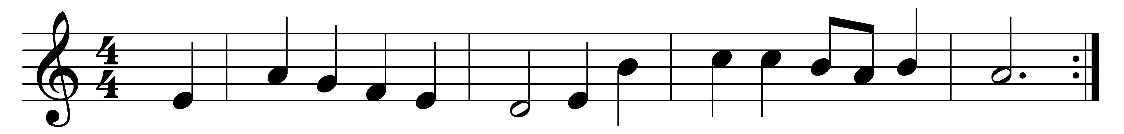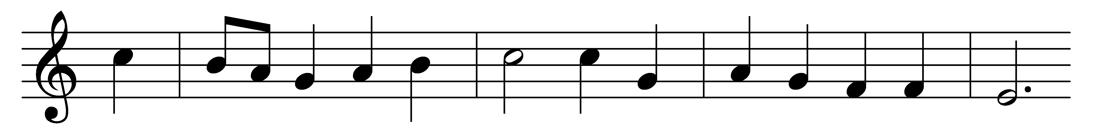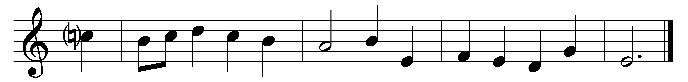

O sacred head, sore wounded,
defiled and put to scorn;
O kingly head, surrounded
with mocking crown of thorn:
what sorrow mars thy grandeur?
Can death thy bloom deflower?
O countenance whose splendor
the hosts of heaven adore!

Thy beauty, long-desirèd,
hath vanished from our sight;
thy power is all expirèd,
and quenched the light of light.
Ah me! for whom thou diest,
hide not so far thy grace:
show me, O Love most highest,
the brightness of thy face.

In thy most bitter passion
my heart to share doth cry,
with thee for my salvation
upon the cross to die.
Ah, keep my heart thus movèd
to stand thy cross beneath,
to mourn thee, well-belovèd,
yet thank thee for thy death.

What language shall I borrow
to thank thee, dearest friend,
for this thy dying sorrow,
thy pity without end?
Oh, make me thine for ever!
and should I fainting be,
Lord, let me never, never,
outlive my love for thee.

My days are few, O fail not,
with thine immortal power,
to hold me that I quail not
in death’s most fearful hour;
that I may fight befriended,
and see in my last strife
to me thine arms extended
upon the cross of life.

Words: Paul Gerhardt (1607-1676), translated by Robert Seymour Bridges (1844-1930) and James Waddell Alexander (1804-1859)
Music: Hans Leo Hassler (1564-1612), arranged by Johann Sebastian Bach (1685-1750)

