Ah, holy Jesus, how hast thou offended Hymnal 1982 no. 158
Melody: Herzliebster Jesu 11 11. 11 5.

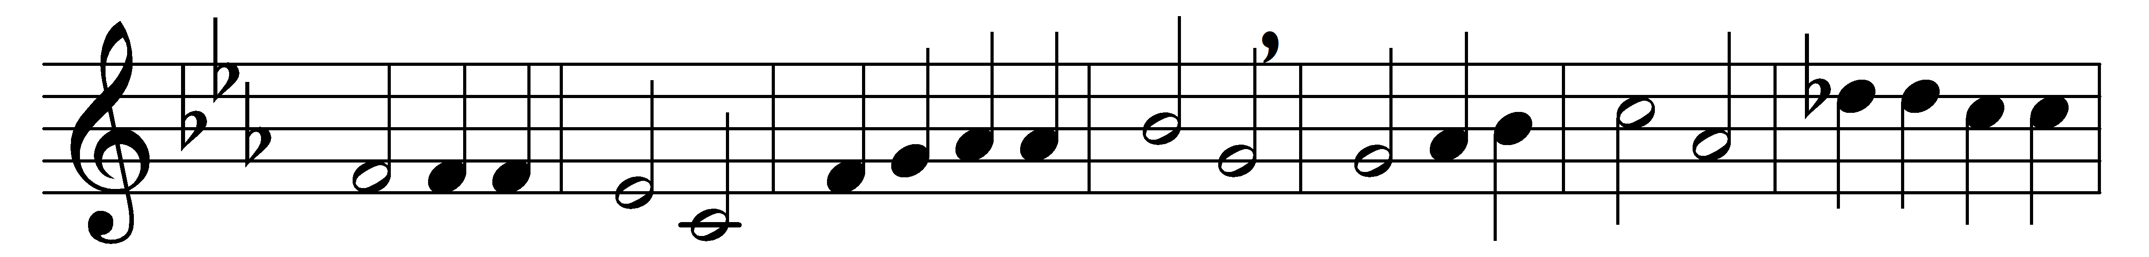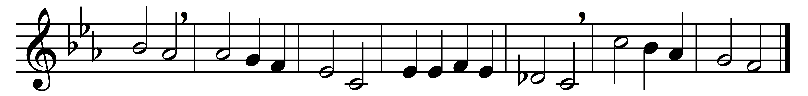

Ah, holy Jesus, how hast thou offended,
that man to judge thee hath in hate pretended?
By foes derided, by thine own rejected,
O most afflicted.

Who was the guilty? Who brought this upon thee?
Alas, my treason, Jesus, hath undone thee.
’Twas I, Lord Jesus, I it was denied thee:
I crucified thee.

Lo, the Good Shepherd for the sheep is offered;
the slave hath sinnèd, and the Son hath suffered;
for our atonement, while we nothing heeded,
God interceded.

For me, kind Jesus, was thy incarnation,
thy mortal sorrow, and thy life’s oblation;
thy death of anguish and thy bitter passion,
for my salvation.

Therefore, kind Jesus, since I cannot pay thee,
I do adore thee, and will ever pray thee,
think on thy pity and thy love unswerving,
not my deserving.

Words: Johann Heermann (1585-1647), translated by Robert Seymour Bridges (1844-1930)
Music: Johann Crüger (1598-1662)

