From deepest woe I cry to thee Hymnal 1982 no. 151 Melody: Aus tiefer Not 8 7. 8 7. 8 8 7.

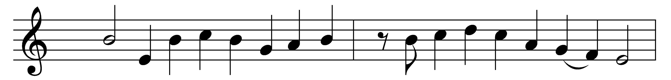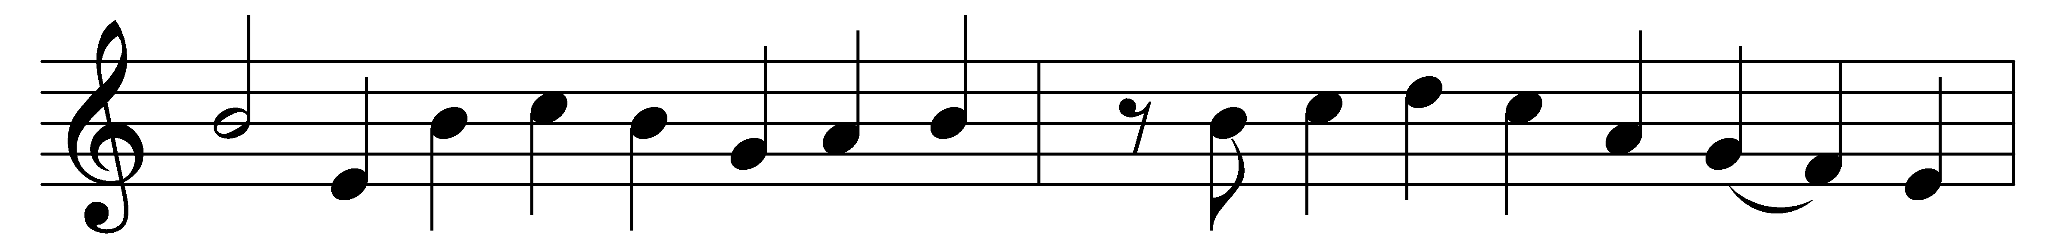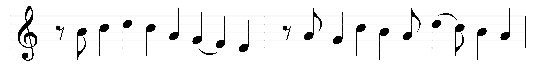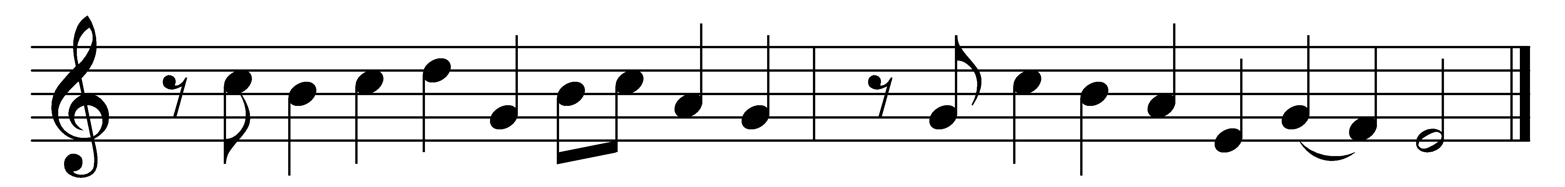

From deepest woe I cry to thee;
Lord, hear me, I implore thee!
Bend down thy gracious ear to me;
I lay my sins before thee.
If thou remember’st every sin,
if nought but just reward we win,
could we abide thy presence?

Thou grantest pardon through thy love;
thy grace alone availeth.
Our works could ne’er our guilt remove;
yea, e’en the best life faileth.
For none may boast themselves of aught,
but must confess thy grace hath wrought
whate’er in them is worthy.

And thus my hope is in the Lord,
and not in my own merit;
I rest upon his faithful word
to them of contrite spirit.
That he is merciful and just,
here is my comfort and my trust;
his help I wait with patience.

Words: Martin Luther (1483-1546), translated by Catherine Winkworth (1827-1878)
Music: Melody attributed to Martin Luther (1483-1546), harmony by Johann Herman Schein (1586-1630)

