Now quit your care and anxious fear and worry Hymnal 1982 no. 145
Melody: Quittez, Pasteurs Irregular metre
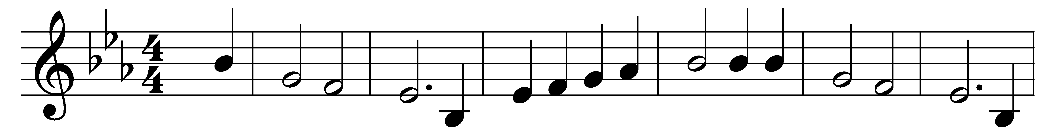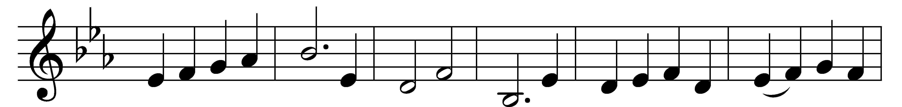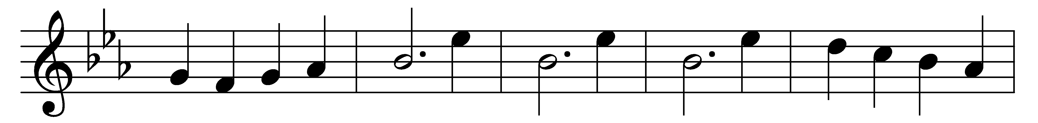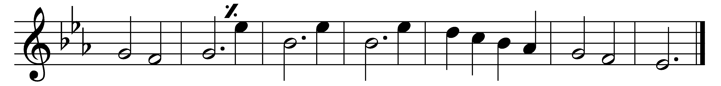

Now quit your care and anxious fear and worry;
for schemes are vain and fretting brings no gain.
Lent calls to prayer, to trust and dedication;
God brings new beauty nigh;
reply, reply, reply with love to love most high.

To bow the head in sackcloth and in ashes,
or rend the soul, such grief is not Lent’s goal;
but to be led to where God’s glory flashes,
his beauty to come near.
Make clear, make clear, make clear where truth and light appear.

For is not this the fast that I have chosen?
(The prophet spoke) To shatter every yoke,
of wickedness the grievous bands to loosen,
oppression put to flight,
to fight, to fight, to fight till every wrong’s set right.

For righteousness and peace will show their faces
to those who feed the hungry in their need,
and wrongs redress, who build the old waste places,
and in the darkness shine.
Divine, divine, divine it is when all combine!

Then shall your light break forth as doth the morning;
your health shall spring, the friends you make shall bring
God’s glory bright, your way through life adorning;
and love shall be the prize.
Arise, arise, arise! and make a paradise!

Words: Percy Dearmer (1867-1936)
Music: French carol

