The glory of these forty days Hymnal 1982 no. 143 Melody: Erhalt uns, Herr L.M.
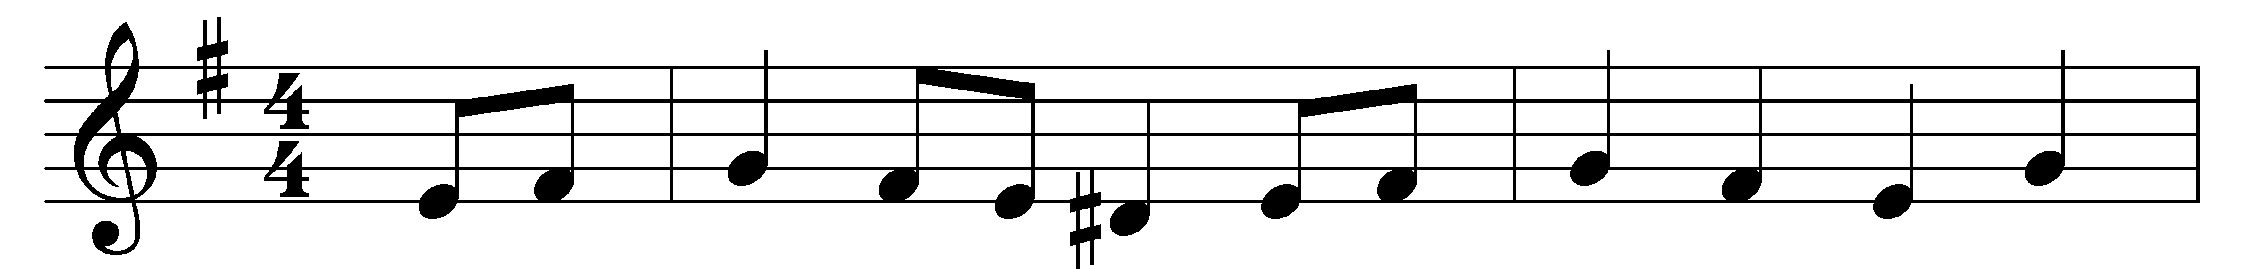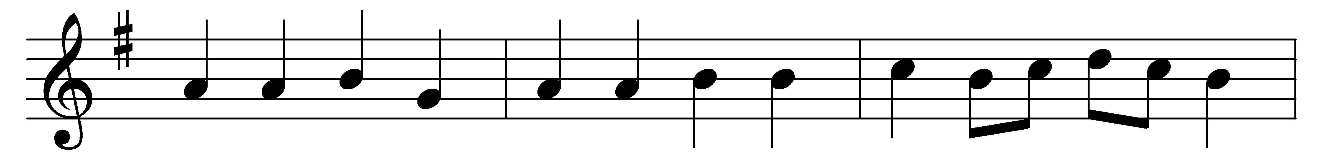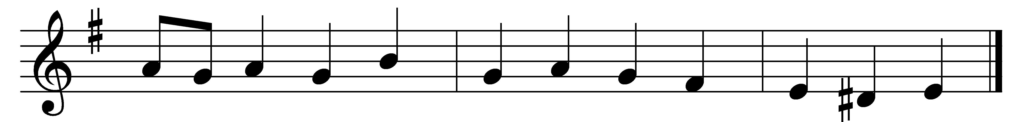

The glory of these forty days
we celebrate with songs of praise;
for Christ, through whom all things were made,
himself has fasted and has prayed.

Alone and fasting Moses saw
the loving God who gave the law;
and to Elijah, fasting, came
the steeds and chariots of flame.

So Daniel trained his mystic sight,
delivered from the lions’ might;
and John, the Bridegroom’s friend, became
the herald of Messiah’s name.

Then grant us, Lord, like them to be
full oft in fast and prayer with thee;
our spirits strengthen with thy grace,
and give us joy to see thy face.

O Father, Son, and Spirit blest,
to thee be every prayer addressed,
who art in three-fold Name adored,
from age to age, the only Lord.

Words: Latin, 6th century, translated by Maurice Frederick Bell (1862-1947)
Music: Melody from Geistliche Lieder, 1543, harmonised by Johann Sebastian Bach (1685-1750)

