Lord, who throughout these forty days Hymnal 1982 no. 142
Melody: St. Flavian (tune 332) C.M.
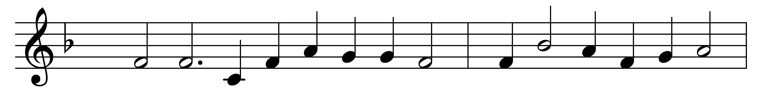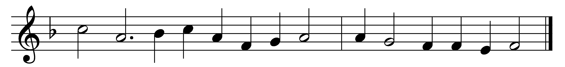

Lord, who throughout these forty days
for us didst fast and pray,
teach us with thee to mourn our sins,
and close by thee to stay.

As thou with Satan didst contend
and didst the victory win,
O give us strength in thee to fight,
in thee to conquer sin.

As thou didst hunger bear and thirst,
so teach us, gracious Lord,
to die to self, and chiefly live
by thy most holy word.

And through these days of penitence,
and through thy Passiontide,
yea, evermore, in life and death,
Jesus! with us abide.

Abide with us, that so, this life
of suffering overpast,
an Easter of unending joy
we may attain at last!

Words: Claudia Frances Hernaman (1838-1898)
Music: From Day’s Psalter, 1562

