All praise to you, O Lord Hymnal 1982 no. 138 Melody: Carlisle S.M.
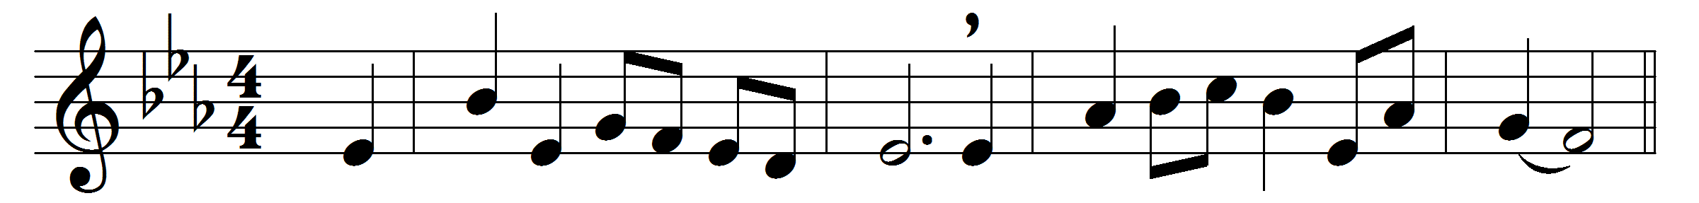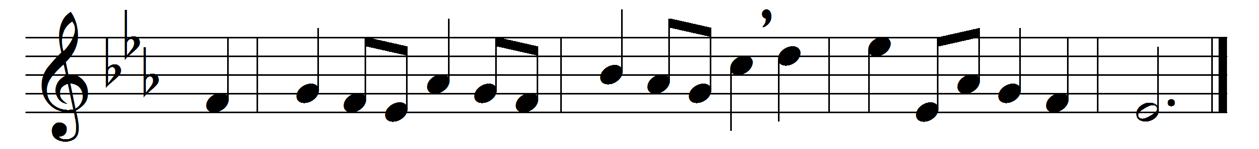

All praise to you, O Lord,
who by your mighty power
did manifest your glory forth
in Cana’s marriage hour.

You speak, and it is done;
obedient to your word,
the water reddening into wine
proclaims the present Lord.

Oh, may this grace be ours:
in you always to live
and drink of those refreshing streams
which you alone can give.

So, led from strength to strength,
grant us, O Lord, to see
the marriage supper of the Lamb,
the great epiphany.

Words: Hyde Wyndham Beadon (1812-1891)
Music: Charles Lockhart (1745-1815)

