O wondrous type! O vision fair Hymnal 1982 no. 136 Melody: Aeterne Rex altissime L.M.
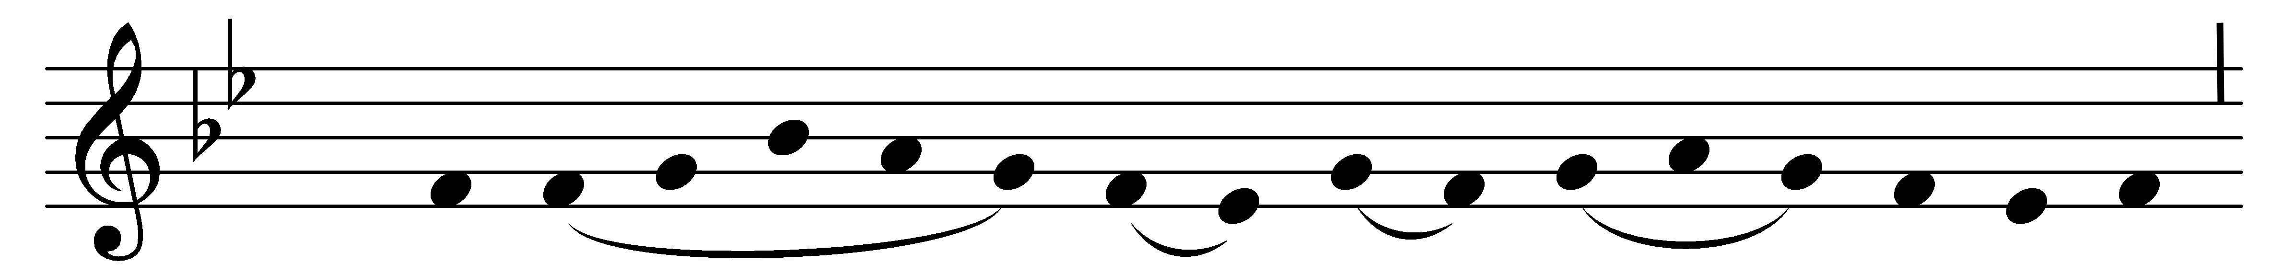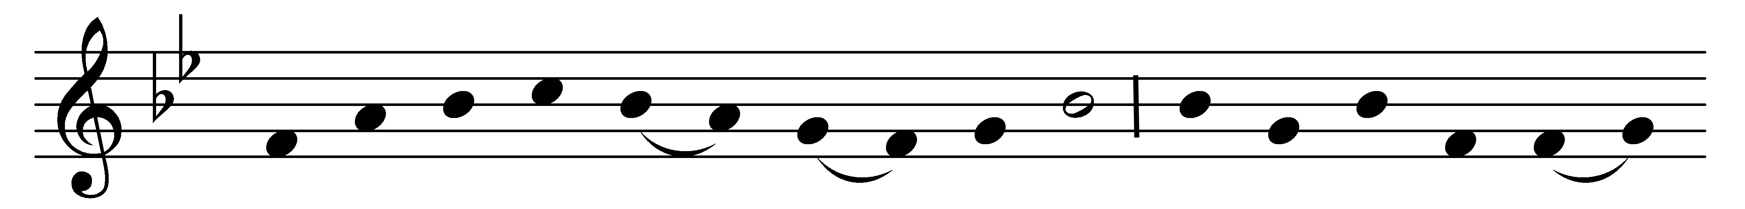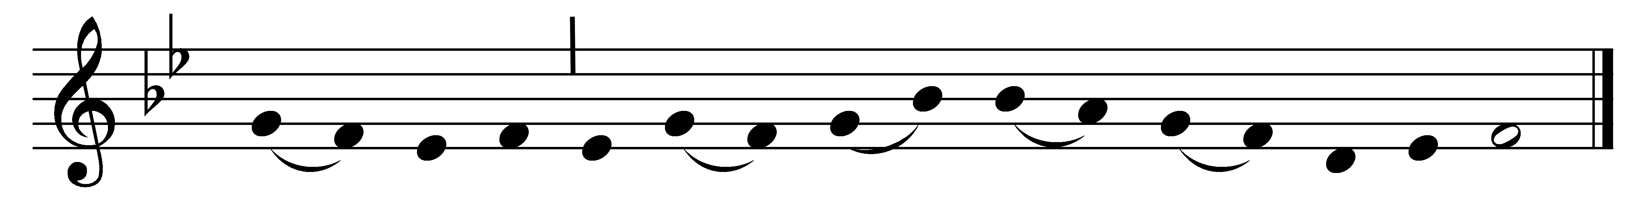

O wondrous type! O vision fair
of glory that the Church may share,
which Christ upon the mountain shows,
where brighter than the sun he glows!

With Moses and Elijah nigh
th’ incarnate Lord holds converse high;
and from the cloud, the Holy One
bears record to the only Son.

With shining face and bright array,
Christ deigns to manifest today
what glory shall be theirs above
who joy in God with perfect love.

And faithful hearts are raised on high
by this great vision’s mystery;
for which in joyful strains we raise
the voice of prayer, the hymn of praise.

O Father, with th’ eternal Son,
and Holy Spirit, ever One,
vouchsafe to bring us by thy grace
to see thy glory face to face.

Words: Latin, 15th century, translation based on John Mason Neale (1818-1866)
Music: Mode i, Zisterzienser Hymnar, 14th century

