We three kings of Orient are Hymnal 1982 no. 128
Melody: Three Kings of Orient 8 8. 4 4 6. with refrain
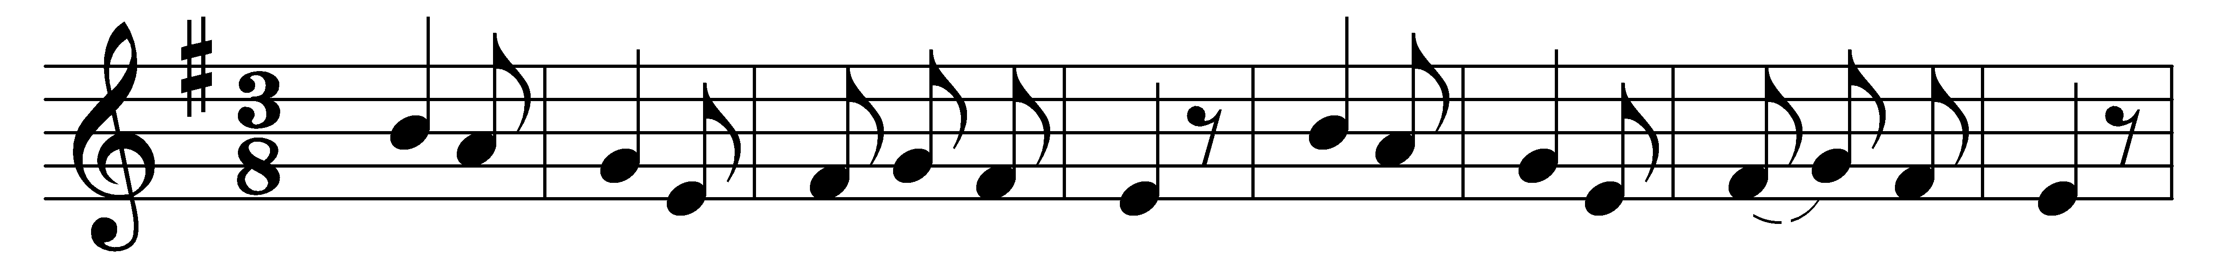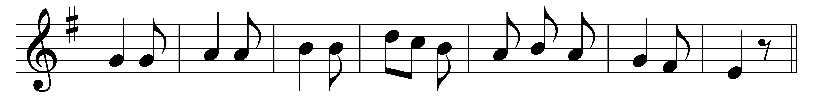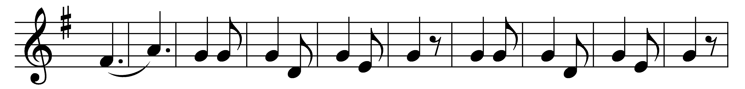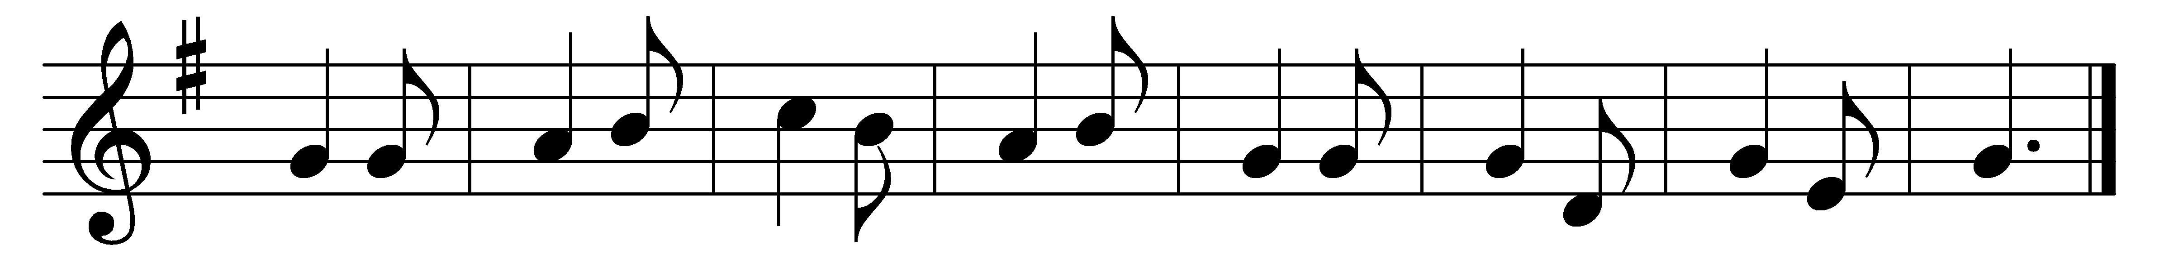

We three kings of Orient are,
bearing gifts we traverse afar,
field and fountain,
moor and mountain,
following yonder star.
(Refrain:) O star of wonder, star of night,
star with royal beauty bright;
westward leading, still proceeding,
guide us to thy perfect light!

Born a King on Bethlehem’s plain,
gold I bring to crown him again,
King for ever,
ceasing never
over us all to reign. (Refrain)

Frankincense to offer have I:
incense owns a Deity nigh;
prayer and praising,
gladly raising,
worship him, God Most High. (Refrain)

Myrrh is mine; its bitter perfume
breathes a life of gathering gloom;
sorrowing, sighing,
bleeding, dying,
sealed in the stone-cold tomb. (Refrain)

Glorious now behold him arise,
King and God and Sacrifice;
heaven sings alleluia:
alleluia the earth replies. (Refrain)

Words and music: John Henry Hopkins, Jr. (1820-1891)

