What star is this, with beams so bright Hymnal 1982 no. 124 Melody: Puer Nobis Nascitur L.M.
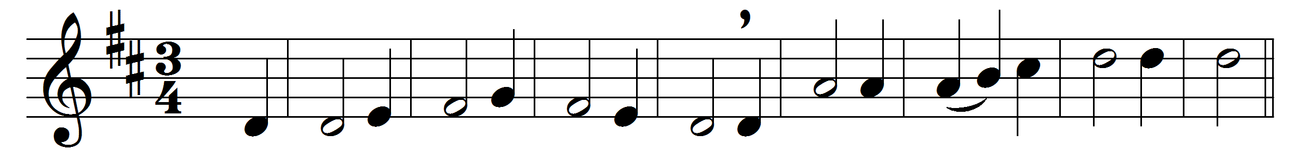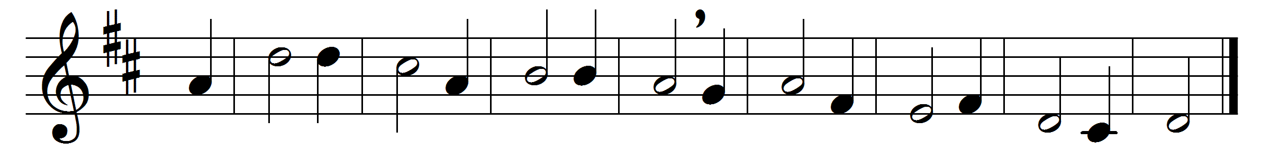

What star is this, with beams so bright,
more beauteous than the noonday light?
It shines to herald forth the King,
and Gentiles to his crib to bring.

True spake the prophet from afar
who told the rise of Jacob’s star;
and eastern sages with amaze
upon the wondrous token gaze.

The guiding star above is bright;
within them shines a clearer light,
and leads them on with power benign
to seek the Giver of the sign.

O Jesus, while the star of grace
impels us on to seek thy face,
let not our slothful hearts refuse
the guidance of thy light to use.

To God the Father, heavenly Light,
to Christ, revealed in earthly night,
to God the Holy Ghost we raise
our equal and unceasing praise.

Words: Charles Coffin (1676-1749), translation based on John Chandler (1807-1876)
Music: Melody by Michael Praetorius (1571-1621), harmony by George Ratcliffe Woodward (1848-1934)

