Alleluia, song of gladness Hymnal 1982 no. 122 Melody: Dulce carmen 8 7. 8 7. 8 7.

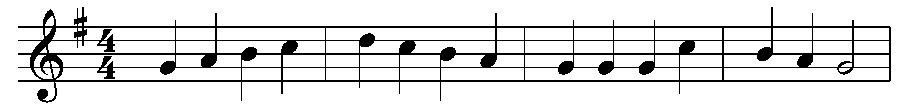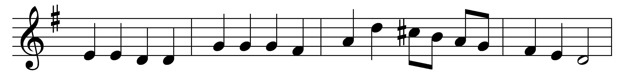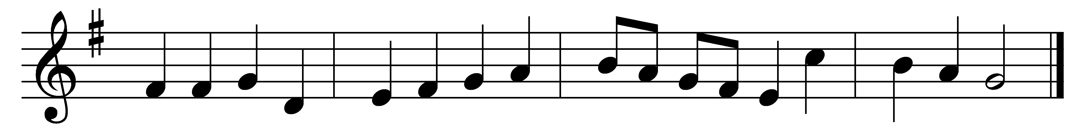

Alleluia, song of gladness,
voice of joy that cannot die;
alleluia is the anthem
ever raised by choirs on high;
in the house of God abiding
thus they sing eternally.

Alleluia thou resoundest,
true Jerusalem and free;
alleluia, joyful mother,
all thy children sing with thee;
but by Babylon’s sad waters
mourning exiles now are we.

Alleluia though we cherish
and would chant for evermore
alleluia in our singing,
let us for a while give o’er,
as our Savior in his fasting
pleasures of the world forbore.

Therefore in our hymns we pray thee,
grant us, blessèd Trinity,
at the last to keep thine Easter
with thy faithful saints on high;
there to thee for ever singing
alleluia joyfully.

Words: Latin, 11th century, translated by John Mason Neale (1818-1866)
Music: Melody from An Essay on the Church Plain Chant, 1782, adapted in the Collection of Motetts or Antiphons, c. 1840, harmonised by William Henry Monk (1823-1889)

