Brightest and best of the stars of the morning Hymnal 1982 no. 118
Melody: Star in the East 11 10. 11 10.
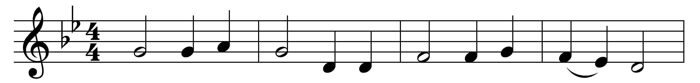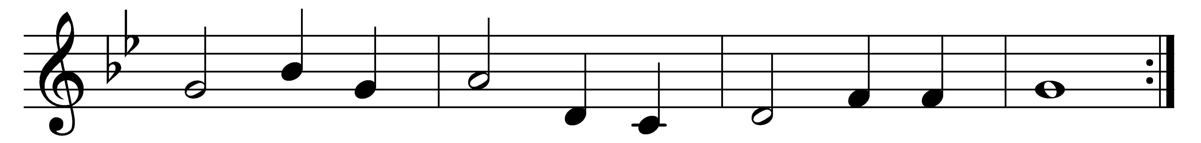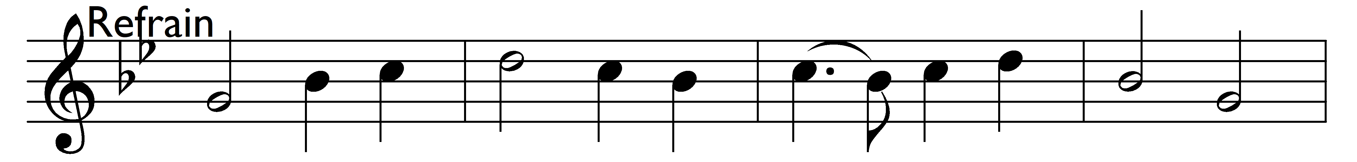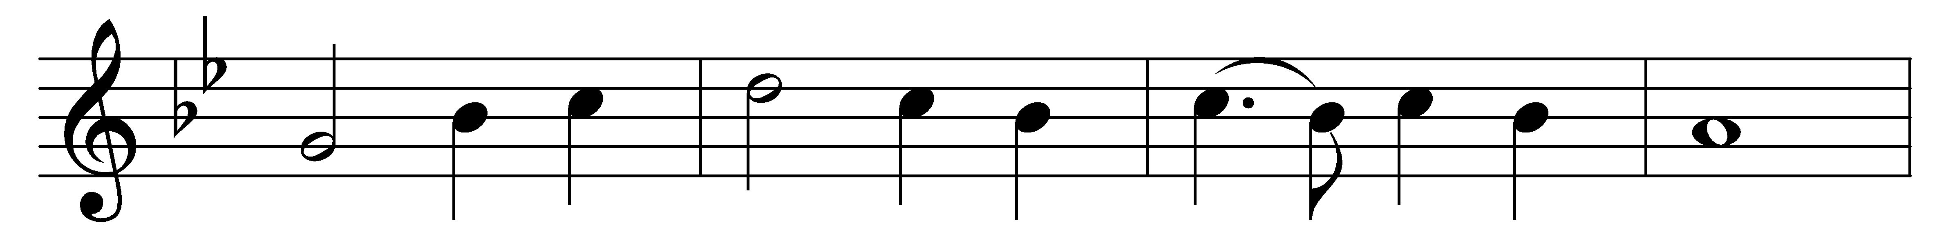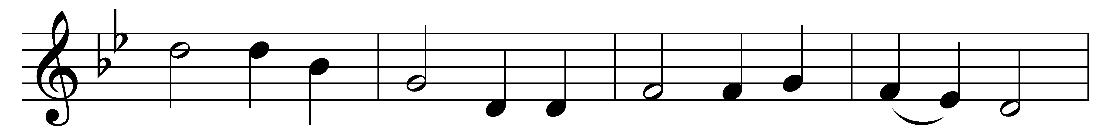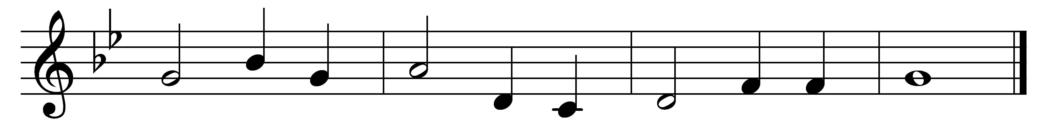
Brightest and best of the stars of the morning,
dawn on our darkness, and lend us thine aid;
star of the east, the horizon adorning,
guide where our infant Redeemer is laid.
(Refrain:) Brightest and best of the stars of the morning,
dawn on our darkness, and lend us thine aid;
star of the east, the horizon adorning,
guide where our infant Redeemer is laid.

Cold on his cradle the dew-drops are shining,
low lies his head with the beasts of the stall;
angels adore him in slumber reclining,
Maker and Monarch and Savior of all.
(Refrain)

Shall we then yield him, in costly devotion,
odors of Edom, and offerings divine,
gems of the mountain, and pearls of the ocean,
myrrh from the forest, and gold from the mine?
(Refrain)

Vainly we offer each ample oblation,
vainly with gifts would his favor secure,
richer by far is the heart’s adoration,
dearer to God are the prayers of the poor.
(Refrain)

Brightest and best of the stars of the morning,
dawn on our darkness, and lend us thine aid;
star of the east, the horizon adorning,
guide where our infant Redeemer is laid.
(Refrain)

Words: Reginald Heber (1783-1826)
Music: From The Southern Harmony, 1835

