What child is this, who, laid to rest Hymnal 1982 no. 115
Melody: Greensleeves 8 7. 8 7. with refrain
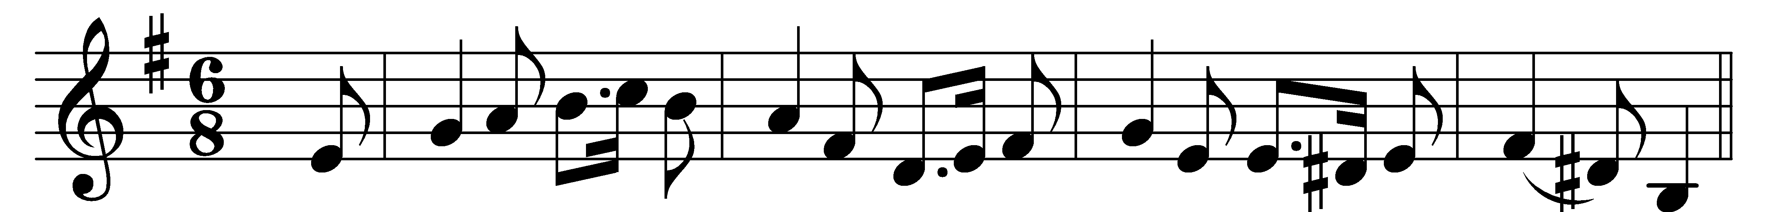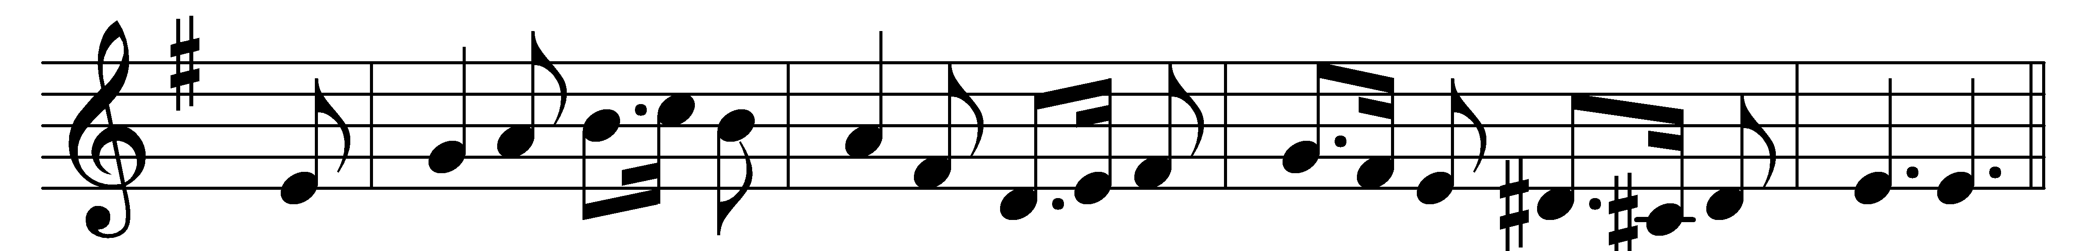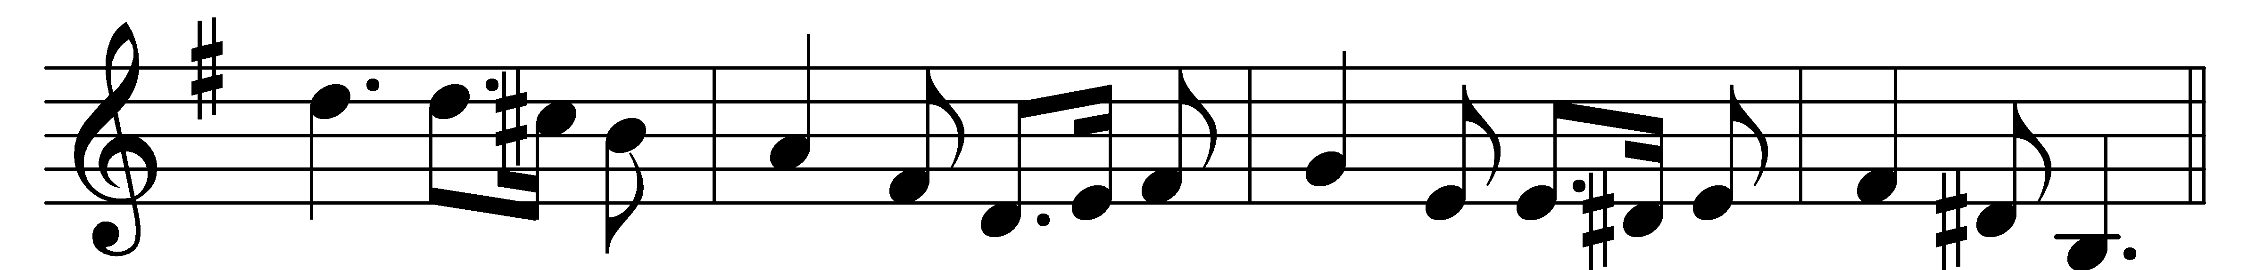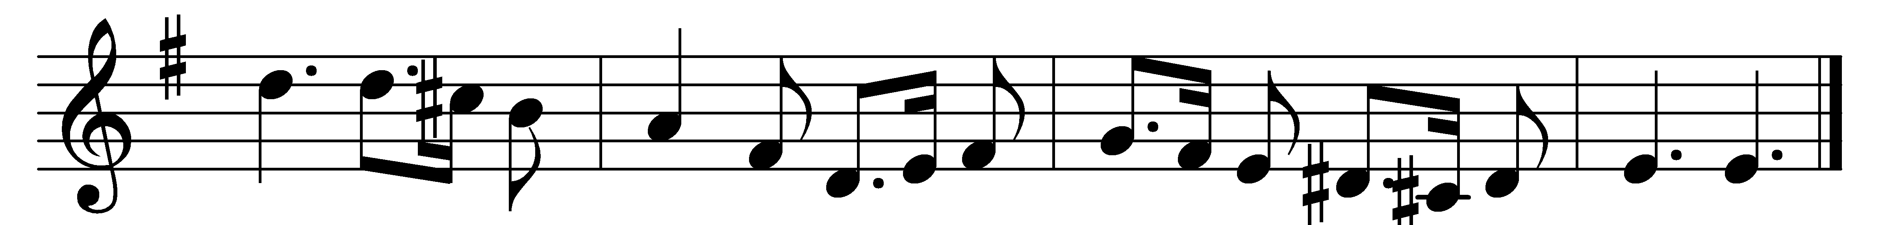

What child is this, who, laid to rest,
on Mary’s lap is sleeping?
Whom angels greet with anthems sweet,
while shepherds watch are keeping?
(Refrain:) This, this is Christ the King,
whom shepherds guard and angels sing;
haste, haste to bring him laud,
the babe, the son of Mary.

Why lies he in such mean estate
where ox and ass are feeding?
Good Christian, fear: for sinners here
the silent Word is pleading.
Refrain

So bring him incense, gold, and myrrh;
come, peasant, king, to own him;
the King of kings salvation brings,
let loving hearts enthrone him.
Refrain

Words: William Chatterton Dix (1837-1898)
Music: English melody, harmony from Christmas Carols New and Old (1871)

