Silent night, holy night Hymnal 1982 no. 111 Melody: Stille Nacht Irregular metre
British spelling
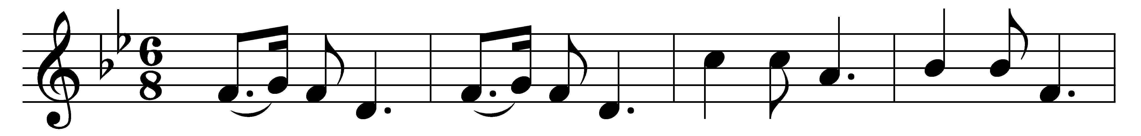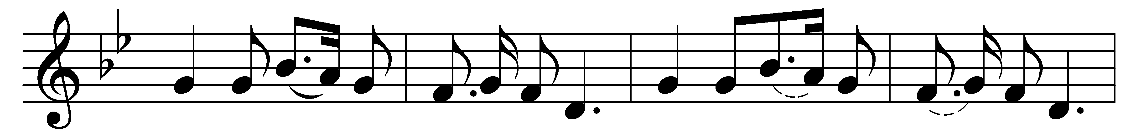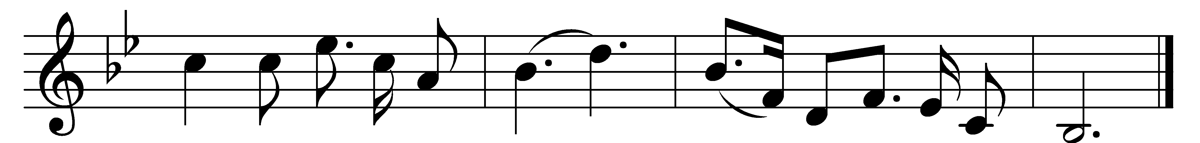

Silent night, holy night,
all is calm, all is bright
round yon virgin mother and child.
Holy infant, so tender and mild,
sleep in heavenly peace.
Sleep in heavenly peace.

Silent night, holy night,
shepherds quake at the sight;
glories stream from heaven afar,
heavenly hosts sing alleluia;
Christ, the Saviour, is born!
Christ, the Saviour, is born!

Silent night, holy night,
Son of God, love’s pure light
radiant beams from thy holy face,
with the dawn of redeeming grace,
Jesus, Lord, at thy birth.
Jesus, Lord, at thy birth.

Words: Joseph Mohr (1792-1848), translated by John Freeman Young (1820-1885)
Music: Melody by Franz Xaver Gruber (1787-1863), harmonised by Carl Heinrich Carsten Reinecke (1824-1910)

