The first Nowell the angel did say Hymnal 1982 no. 109
Melody: The First Nowell Irregular metre
British spelling
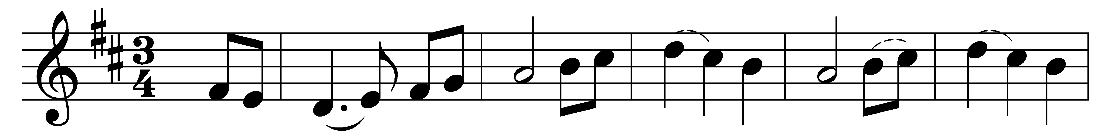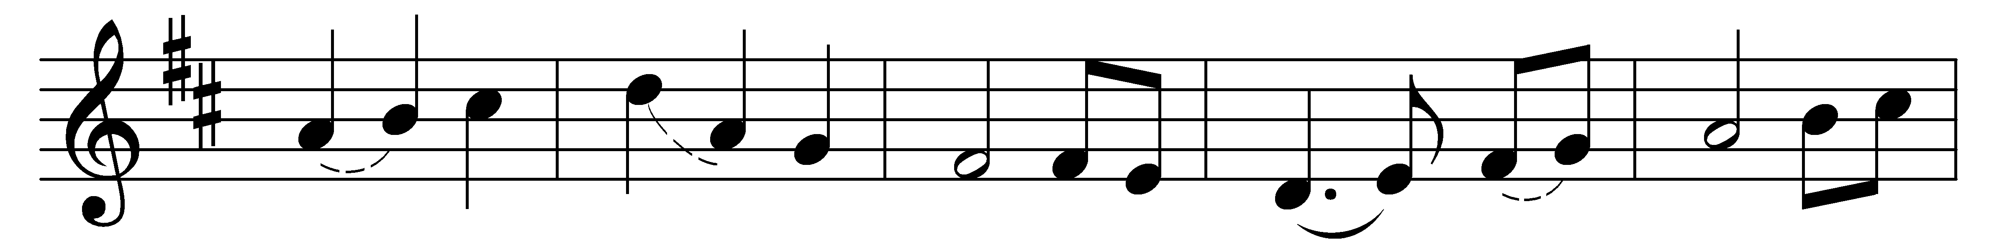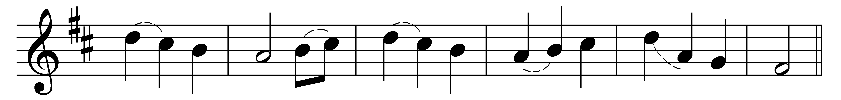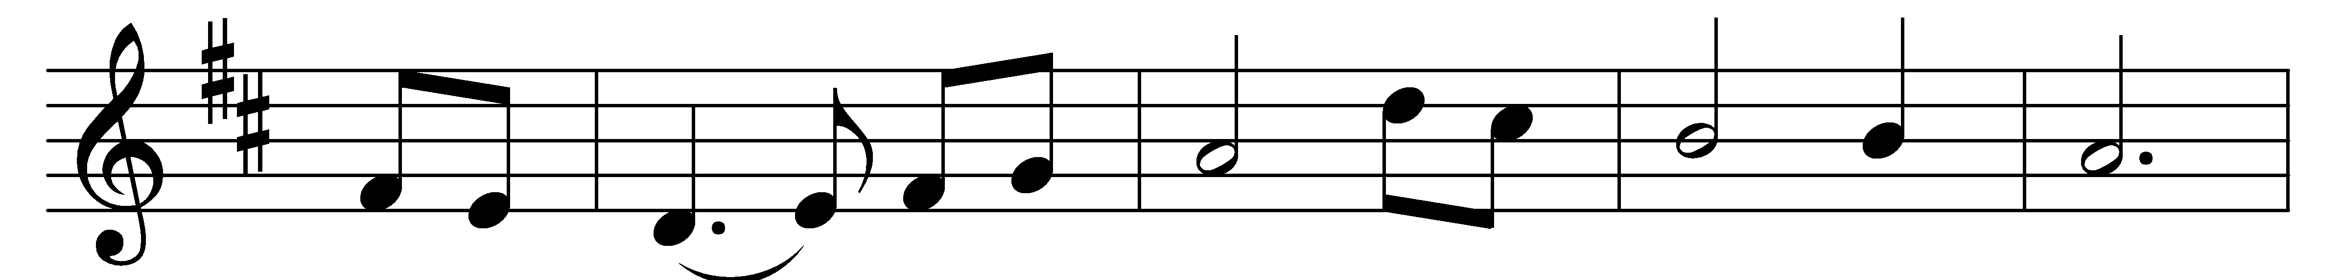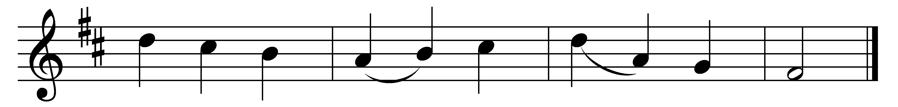

The first Nowell the angel did say
was to certain poor shepherds in fields as they lay;
in fields as they lay, keeping their sheep,
on a cold winter’s night that was so deep.
(Refrain:) Nowell, Nowell, Nowell, Nowell,
born is the King of Israel.

They lookèd up and saw a star
shining in the east beyond them far,
and to the earth it gave great light,
and so it continued both day and night.
(Refrain)

And by the light of that same star
three wise men came from country far;
to seek for a king was their intent,
and to follow the star wherever it went.
(Refrain)

This star drew nigh to the northwest,
o’er Bethlehem it took its rest,
and there it did both stop and stay
right over the place where Jesus lay.
(Refrain)

Then entered in those wise men three
full reverently upon their knee,
and offered there in his presence
their gold, and myrrh, and frankincense.
(Refrain)

Then let us all with one accord
sing praises to our heavenly Lord;
that hath made heaven and earth of naught,
and with his blood our life hath bought.
(Refrain)

Words: 18th-century English carol
Music: 17th-century English carol, harmonised by John Stainer (1840-1901)

