Good Christian friends, rejoice Hymnal 1982 no. 107 Melody: In dulci jubilo 6 6. 7 7. 7 8. 5 5.
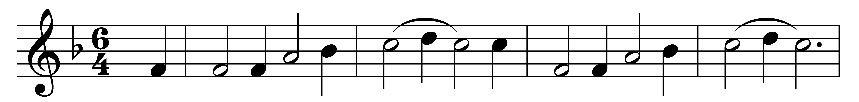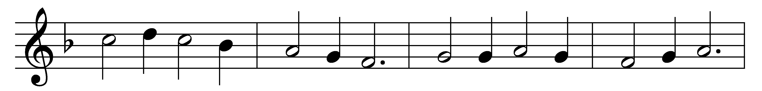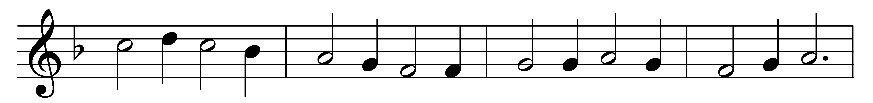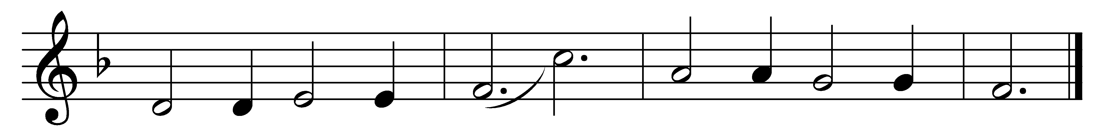

Good Christian friends, rejoice
with heart and soul and voice;
give ye heed to what we say:
Jesus Christ is born today;
ox and ass before him bow,
and he is in the manger now.
Christ is born today!
Christ is born today!

Good Christian friends, rejoice
with heart and soul and voice;
now ye hear of endless bliss;
Jesus Christ was born for this!
He hath opened heaven’s door,
and we are blest for evermore.
Christ was born for this!
Christ was born for this!

Good Christian friends, rejoice
with heart and soul and voice;
now ye need not fear the grave:
Jesus Christ was born to save!
Calls you one and calls you all
to gain his everlasting hall.
Christ was born to save!
Christ was born to save!

Words: John Mason Neale (1818-1866)
Music: 14th-century German carol, harmonised by Charles Winfred Douglas (1867-1944)

