Psalm 82 – Common Worship

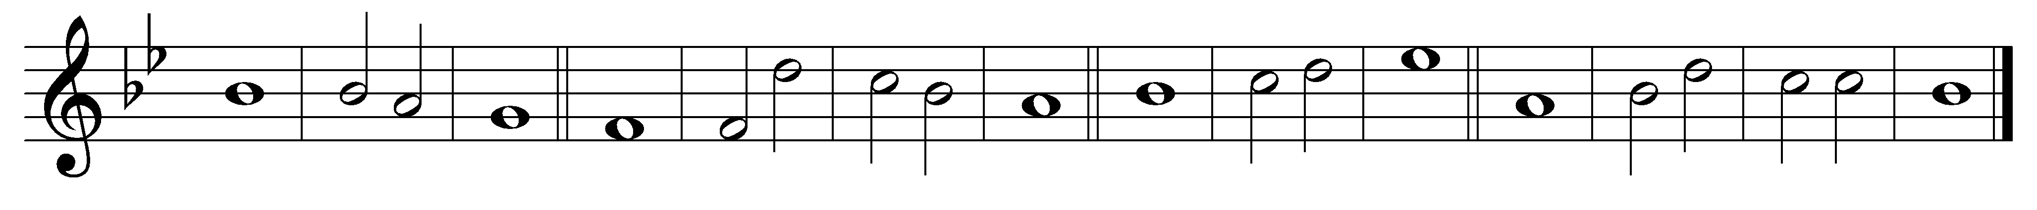

1 God has taken his stand in the | council· of | heaven;
in the midst of the | gods he | gives | judgement:

2 ‘How long will you | judge un-| justly
and show such | favour | to the | wicked?

3 ‘You were to judge the | weak· and the | orphan;
defend the | right· of the | humble· and | needy;

4 ‘Rescue the | weak· and the | poor;
deliver them | from the | hand· of the | wicked.

5 ‘They have no knowledge or wisdom; they walk on | still in | darkness:
all the foun-| dations· of the | earth are | shaken.

6 ‘Therefore I say that | though you· are | gods
and all of you children | of the | Most | High,

7 ‘Nevertheless, you shall | die like | mortals
and | fall like | one of· their | princes.’

8 Arise, O God and | judge the | earth,
for it is you that shall take all | nations· for | your pos-| session.

Words taken from Common Worship © The Archbishops’ Council 2000.

